**SQL Hackathon June 2024**

**--1. What was the average BMI of the mothers and the average fetal weight in Kgs at delivery?**

select round(avg(current_bmi),2) MaternalBMI,round(avg(newborn_weight)/1000,2) fetalweight from public.patient_history

join public.hospitalization_labor

on patient_history.caseid=hospitalization_labor.caseid;

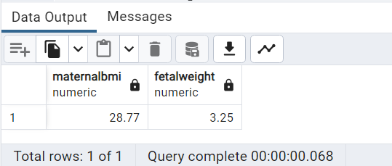

------------------------------------------------------------------------------------------------------------------------------------

**--2. In how many of deliveries did newborn weight come within 5% of expected weight for the newborn?**

with DiffPercent as

(

select caseid,round((((expected_weight_for_the_newborn)-(newborn_weight))/expected_weight_for_the_newborn)*100,2) weightdiff

from public.hospitalization_labor

)

select count(*) from DiffPercent where weightdiff between -5 and 5

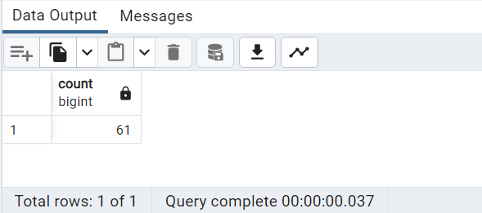

---------------------------------------------------------------------------------------------------------------

**--3. Of all Miscarriages recorded what percentage were drug or alcohol users and what % were not?**

with AlcoholDrugs as

(

select count(distinct patient_history.caseid) AlcoholDrugUsers from public.fetal_health_risk

join public.patient_history on

fetal_health_risk.caseid=patient_history.caseid

join public.hospitalization_labor on

fetal_health_risk.caseid=hospitalization_labor.caseid

where drugs_preference<>'No' and alcohol_use=1

and miscarriage=1

),

NoAlcoholDrugs as

(

select count(distinct patient_history.caseid) teetotalers from public.fetal_health_risk

join public.patient_history on

fetal_health_risk.caseid=patient_history.caseid

join public.hospitalization_labor on

fetal_health_risk.caseid=hospitalization_labor.caseid

where drugs_preference='No' and alcohol_use=0

and miscarriage=1

),

TotalCount as

(

select count(distinct patient_history.caseid) total from public.patient_history

join public.hospitalization_labor on

patient_history.caseid=hospitalization_labor.caseid

where miscarriage=1

)

select Round((sum(AlcoholDrugUsers)/sum(total))*100,2) PercentageDrugs,

round((sum(teetotalers)/sum(total))*100,2) percentageTeetotalers from

AlcoholDrugs, NoAlcoholDrugs, TotalCount;

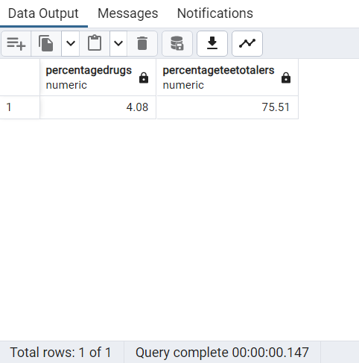

---------------------------------------------------------------------------------------------------------------

**--4. What is the correlation between alcohol and drug use and BMI?**

With DrugsAlcohol as

(

select (sum(alcohol_use)+sum(case when drugs_preference<>'No' then 1 else 0 end)) AD,

avg(coalesce(current_bmi,0)) bmi from public.fetal_health_risk

join public.patient_history on

fetal_health_risk.caseid=patient_history.caseid

group by patient_history.caseid

)

Select corr(AD,bmi) from DrugsAlcohol;

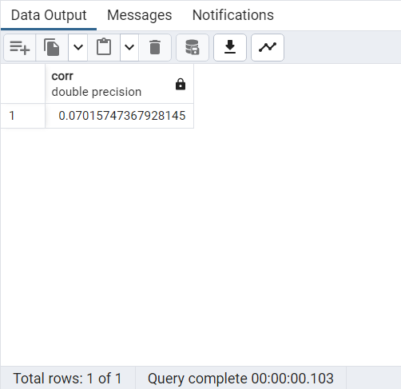

---------------------------------------------------------------------------------------------------------------

**--5. Create a function that takes all lifestyle conditions into account and returns a health score any case_id that is given as input. You can choose the lifestyle conditions and the method by which a score is assigned**

CREATE OR REPLACE FUNCTION GET_HealthScore(INPUT_CID bigint)

RETURNS TABLE (HEALTHSCORE bigint)

LANGUAGE PLPGSQL

AS $$

DECLARE R RECORD;

BEGIN

RETURN QUERY

SELECT sum(coalesce(chronic_diabetes,0)+coalesce(chronic_diseases,0)

+coalesce(hypertension_past_reported,0)+coalesce(diabetes_mellitus_dm_reported,0))

FROM public.hospitalization_labor, public.patient_history

WHERE

hospitalization_labor.caseid=patient_history.caseid and

patient_history.caseid = INPUT_CID;

END;

$$

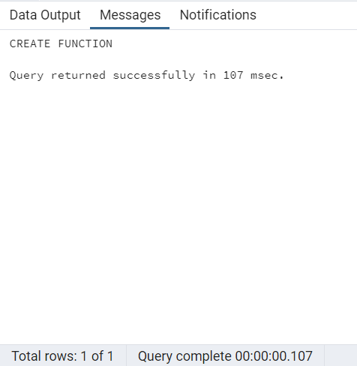

SELECT * FROM GET_HealthScore(7);

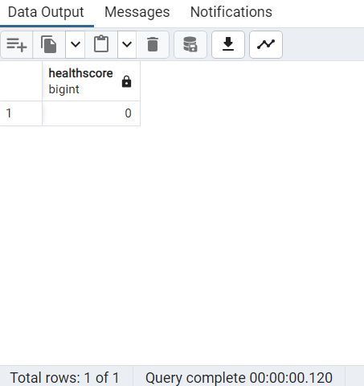

---------------------------------------------------------------------------------------------------------------

**--6. Assuming there are 272 patients what % of all patients reported having hypertension or Diabetes?**

with HTN as

(

select count(*) HTN_DM

from public.patient_history where diabetes_mellitus_dm_reported=1 or hypertension_past_reported=1

)

select round(sum(HTN_DM)/272,2)*100 from HTN

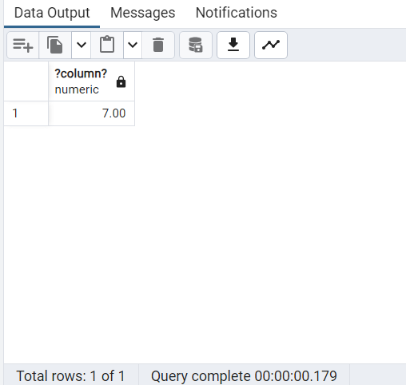

---------------------------------------------------------------------------------------------------------------

**--7. Create a table with patientID and fetal weight in kg. Add an auto generated sequence as the first column**

create table Labor

(

CaseID serial,

patid int,

fetalweight numeric

);

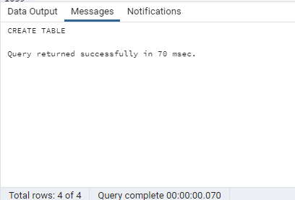

INSERT INTO Labor (patid, fetalweight)

SELECT patient_history.caseid, round((newborn_weight)/1000,2) FROM public.patient_history, public.hospitalization_labor

where patient_history.caseid=hospitalization_labor.caseid

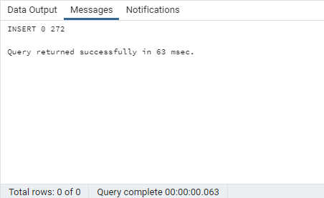

select * from Labor;

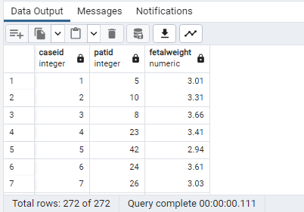

---------------------------------------------------------------------------------------------------------------

**--8. Assuming there are 272 patients. What % of all women have Gestational Diabetes and Of that what % have complications in their delivery?**

with GDM as

(

SELECT count(*) GDMCount FROM public.fetal_health_risk where

gestational_diabetes_mellitus=1

),

complications as

(

select count(*) AllComplications from public.hospitalization_labor

where delivery_mode not like '%Vag%'

),

gdmcomplications as

(

select count(*) GDMComplications from public.hospitalization_labor,public.fetal_health_risk

where

fetal_health_risk.caseid=hospitalization_labor.caseid

and delivery_mode not like '%Vag%'

and gestational_diabetes_mellitus=1

)

Select round((sum(GDMCount)/272)*100,2) PercentGDM_Patients,

round((sum(GDMComplications)/sum(AllComplications))*100,2) PercentageGDMComplications

from GDM,gdmcomplications,complications;

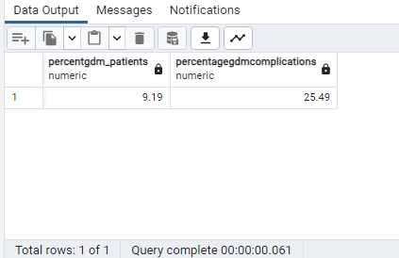

---------------------------------------------------------------------------------------------------------------

**--9. Calculate body fat % using using the 3-site skinfold method**

with sumSkinFold as

(

select (sum(coalesce(mean_tricciptal_skinfold,0))+sum(coalesce(mean_subscapular_skinfold,0))+

sum(coalesce(mean_supra_iliac_skin_fold,0))) sumSkinFolds, caseid

from public.maternal_fat_assmt group by caseid

),

Density as

(

select (1.0994921 - (0.0009929 * sum(sumSkinFolds))+

(0.0000023 * (sum(sumSkinFolds)*sum(sumSkinFolds)))-(0.0001392 * avg(age_years_old))) BodyDensity,

sumSkinFold.caseid Patientno

from public.patient_history,

sumSkinFold where sumSkinFold.caseid=patient_history.caseid

group by 2

)

select round(((495/sum(BodyDensity))-450),2) BodyFat, Patientno from Density group by 2

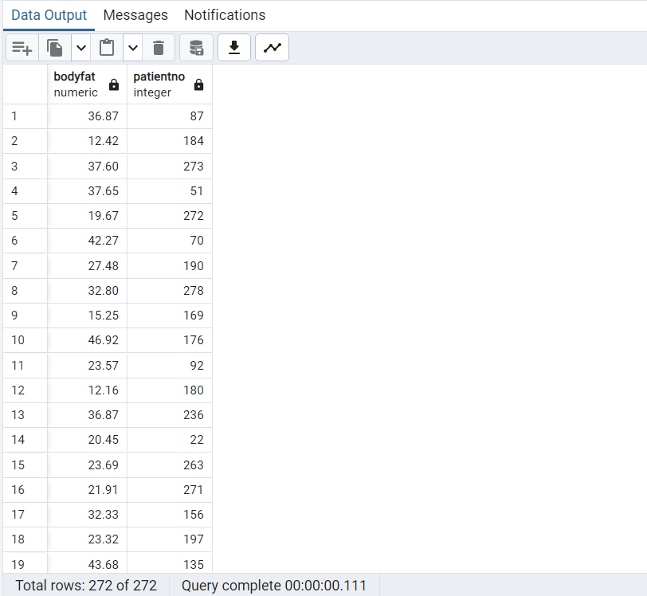

---------------------------------------------------------------------------------------------------------------

**--10. Create a trigger to stop patient records from being deleted from the patient History table**

CREATE OR REPLACE FUNCTION Dont_Delete_Patients()

RETURNS TRIGGER

LANGUAGE plpgsql

AS $$

BEGIN

IF (TG_OP='DELETE') then

RAISE EXCEPTION 'You cannot delete patient records';

END IF;

RETURN null;

END;

$$;

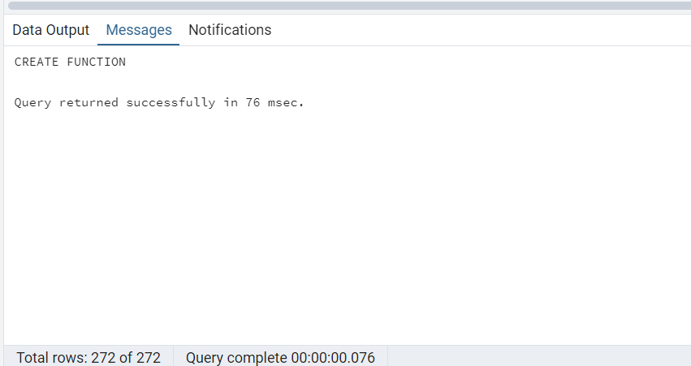

create trigger DonotDelete

before delete on public.patient_history

execute function Dont_Delete_Patients();

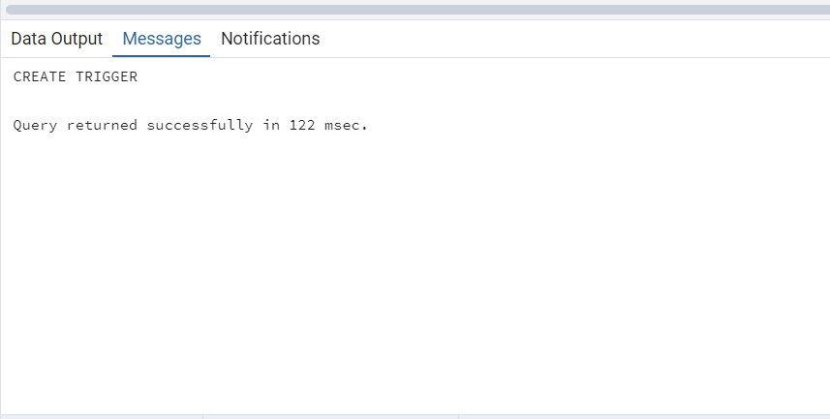

delete from public.patient_history where caseid=2;

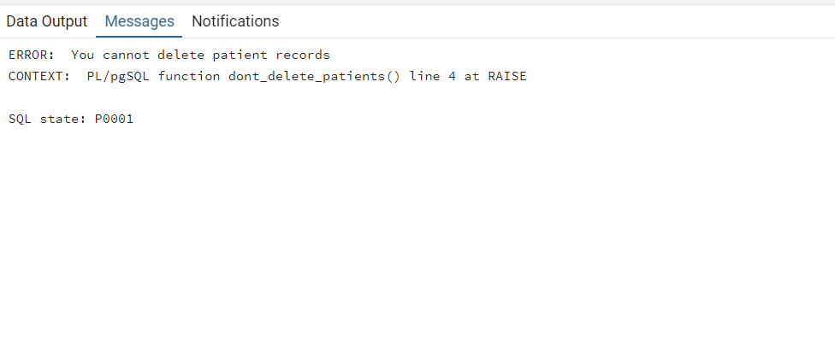

select * from public.patient_history where caseid=2;

---------------------------------------------------------------------------------------------------------------

**--11. What number of all deliveries were cesareans and what were the primary reasons. Display the number against each reason.**

select distinct delivery_mode, count(*) from public.hospitalization_labor where delivery_mode like 'C%' group by 1;

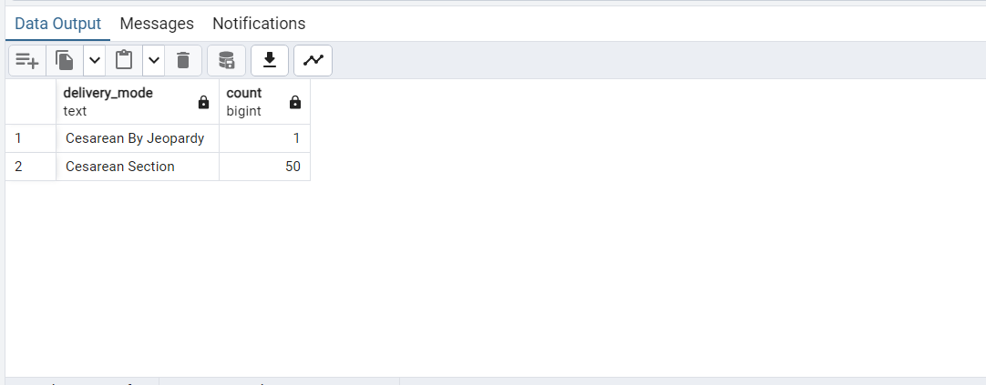

---------------------------------------------------------------------------------------------------------------

**--12. What is the ratio of visceral fat to subcutaneous fat for every patient?**

select (1/sum(periumbilical_visceral_fat+preperitoneal_visceral_fat))* 100 Visceral,

(1/sum(periumbilical_subcutanous_fat+preperitoneal_subcutaneous_fat))*100 Subcutaneous,

caseid

from public.maternal_fat_assmt

where

periumbilical_visceral_fat is not null and preperitoneal_visceral_fat is not null

and periumbilical_subcutanous_fat is not null and preperitoneal_subcutaneous_fat is not null

group by caseid

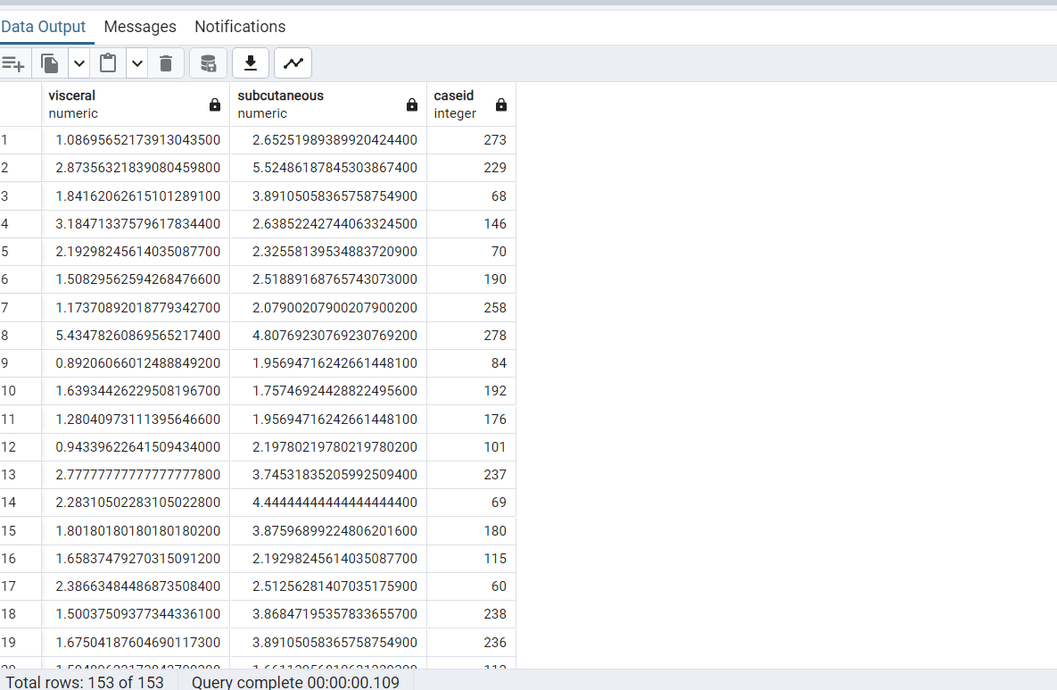

---------------------------------------------------------------------------------------------------------------

**--13. What is the waist:hip circumference ratio for every patient and what category do they fall into: Healthy or Unhealthy?**

with waisthip as

(

select round(avg(maternal_waist_circumference)/avg(maternal_hip_circumference),2) WHRatio,

caseid from public.maternal_fat_assmt group by 2

)

select WHRatio,

case when WHRatio<0.7 then 'Healthy'

when WHRatio isnull then 'Not Recorded' else 'Unhealthy' end,

caseid from waisthip;

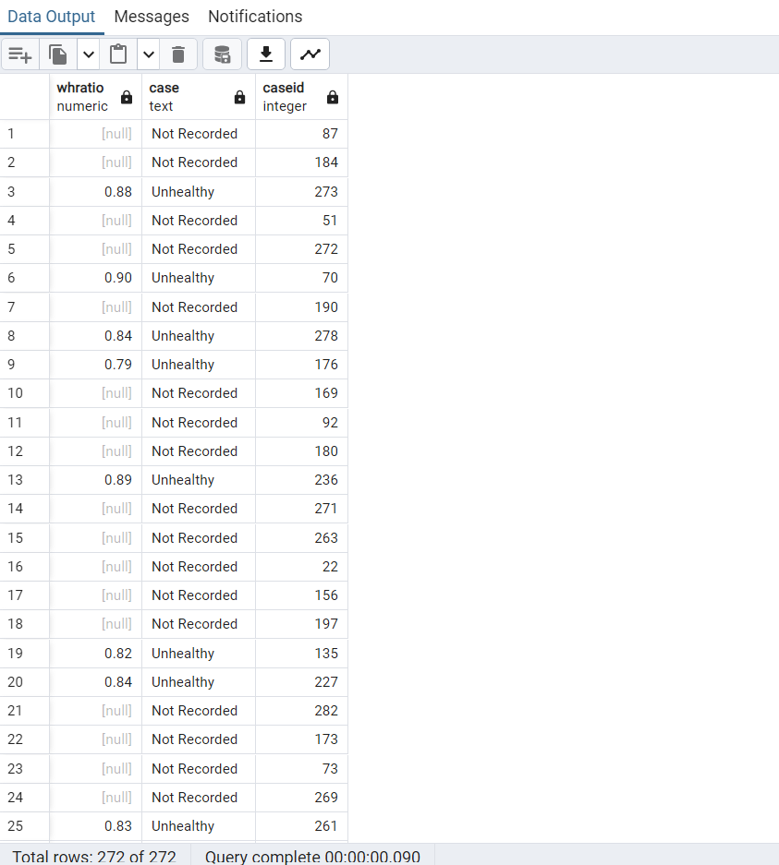

---------------------------------------------------------------------------------------------------------------

**--14. Calculate body fat percentage for every patient using the circumferences provided**

SELECT

495 / (1.29579 - 0.35004 * (LOG10((maternal_waist_circumference + maternal_hip_circumference - maternal_neck_circumference)))

+ 0.22100 * (LOG10(height_at_inclusion*100))) -450 BFPercent , maternal_fat_assmt.caseid

FROM public.patient_history

JOIN public.maternal_fat_assmt ON patient_history.caseid = maternal_fat_assmt.caseid

where maternal_waist_circumference is not null and

maternal_hip_circumference is not null and

maternal_neck_circumference is not null and

height_at_inclusion is not null;

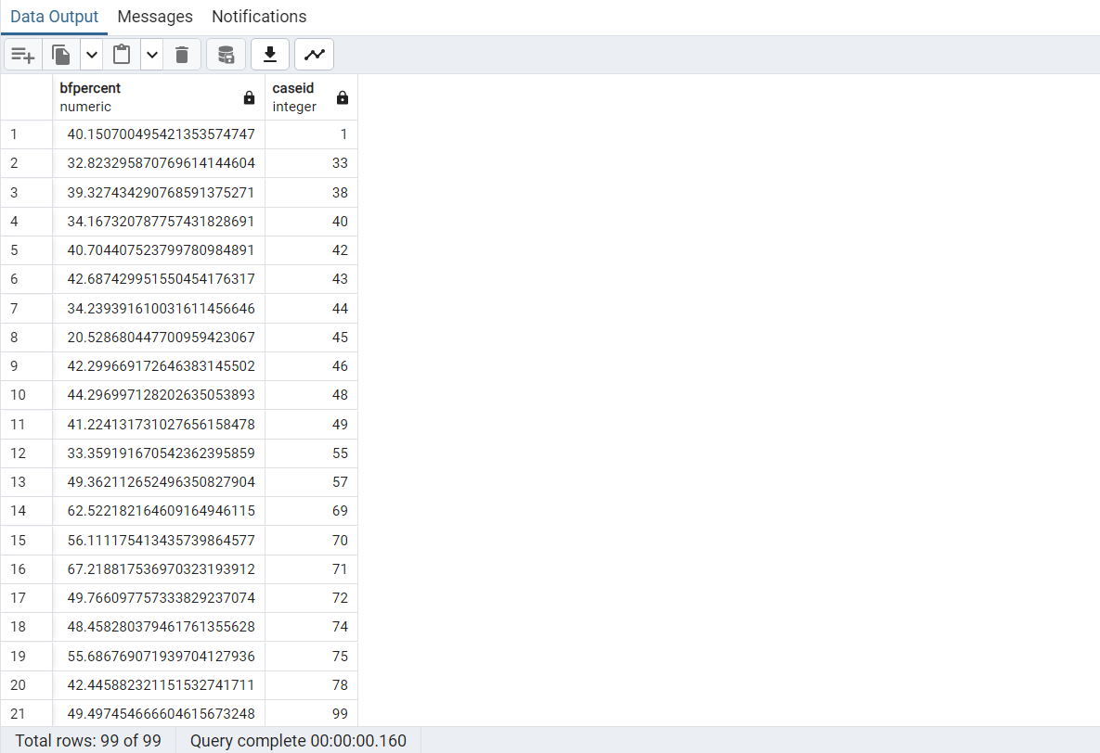

---------------------------------------------------------------------------------------------------------------

**--15. What is the total thickness of visceral fat among patients with a bodyfat>40% by the US Navy Seal Method**

with FatBF as

(

select sum(preperitoneal_visceral_fat+periumbilical_visceral_fat) ThicknessFat,

495 / (1.29579 - 0.35004 * (LOG10((maternal_waist_circumference + maternal_hip_circumference - maternal_neck_circumference)))

+ 0.22100 * (LOG10(height_at_inclusion*100))) -450 BFPercent , maternal_fat_assmt.caseid PatID

FROM public.patient_history

JOIN public.maternal_fat_assmt ON patient_history.caseid = maternal_fat_assmt.caseid

where maternal_waist_circumference is not null and

maternal_hip_circumference is not null and

maternal_neck_circumference is not null and

height_at_inclusion is not null and periumbilical_visceral_fat is not null and preperitoneal_visceral_fat is not null

group by 2,3

)

select ThicknessFat,BFPercent,PatID from FatBF where BFPercent>40;

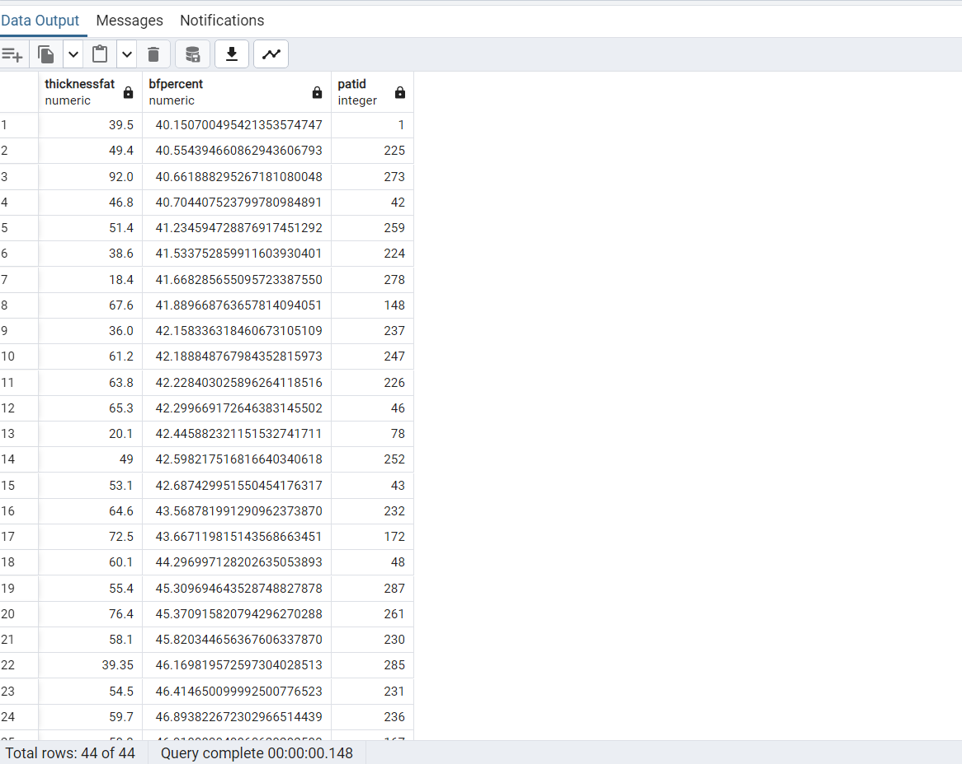

---------------------------------------------------------------------------------------------------------------

**--16. Create a crosstab that displays the count of patients under each delivery mode**

CREATE EXTENSION IF NOT EXISTS tablefunc;

SELECT * FROM CROSSTAB

(

'SELECT

CASE WHEN chronic_diabetes = 1 THEN ''Diabetic'' ELSE ''Non-diabetic'' END AS Diabetes,

delivery_mode DMode,

COUNT(caseid)

FROM public.hospitalization_labor

GROUP BY 1, 2

ORDER BY 1'

) AS CT

(Diabetes text, "Cesarean Section" bigint, "Cesarean By Jeopardy" bigint,

"VaginalVaginal Forcipe" bigint, "Vaginal Forcipe" bigint, "Vaginal" bigint,

"Vaginal W/ Episiotomy and Forcipe" bigint, "Vaginal W/O Episiotomy" bigint, "Vaginal W/ Episiotomy" bigint);

--Alternate Query--

CREATE EXTENSION IF NOT EXISTS tablefunc;

SELECT * FROM CROSSTAB

(

$$

SELECT

CASE WHEN chronic_diabetes = 1 THEN 'Diabetic' ELSE 'Non-diabetic' END AS Diabetes,

delivery_mode AS DMode,

COUNT(caseid)

FROM public.hospitalization_labor

WHERE delivery_mode IS NOT NULL

GROUP BY 1, 2

ORDER BY 1, 2

$$,

$$

SELECT DISTINCT delivery_mode

FROM public.hospitalization_labor

WHERE delivery_mode IS NOT NULL

ORDER BY 1

$$

) AS CT

(

Diabetes text,

"Cesarean Section" bigint,

"Cesarean By Jeopardy" bigint,

"Vaginal Vaginal Forcipe" bigint,

"Vaginal Forcipe" bigint,

"Vaginal" bigint,

"Vaginal W/ Episiotomy and Forcipe" bigint,

"Vaginal W/O Episiotomy" bigint,

"Vaginal W/ Episiotomy" bigint

);

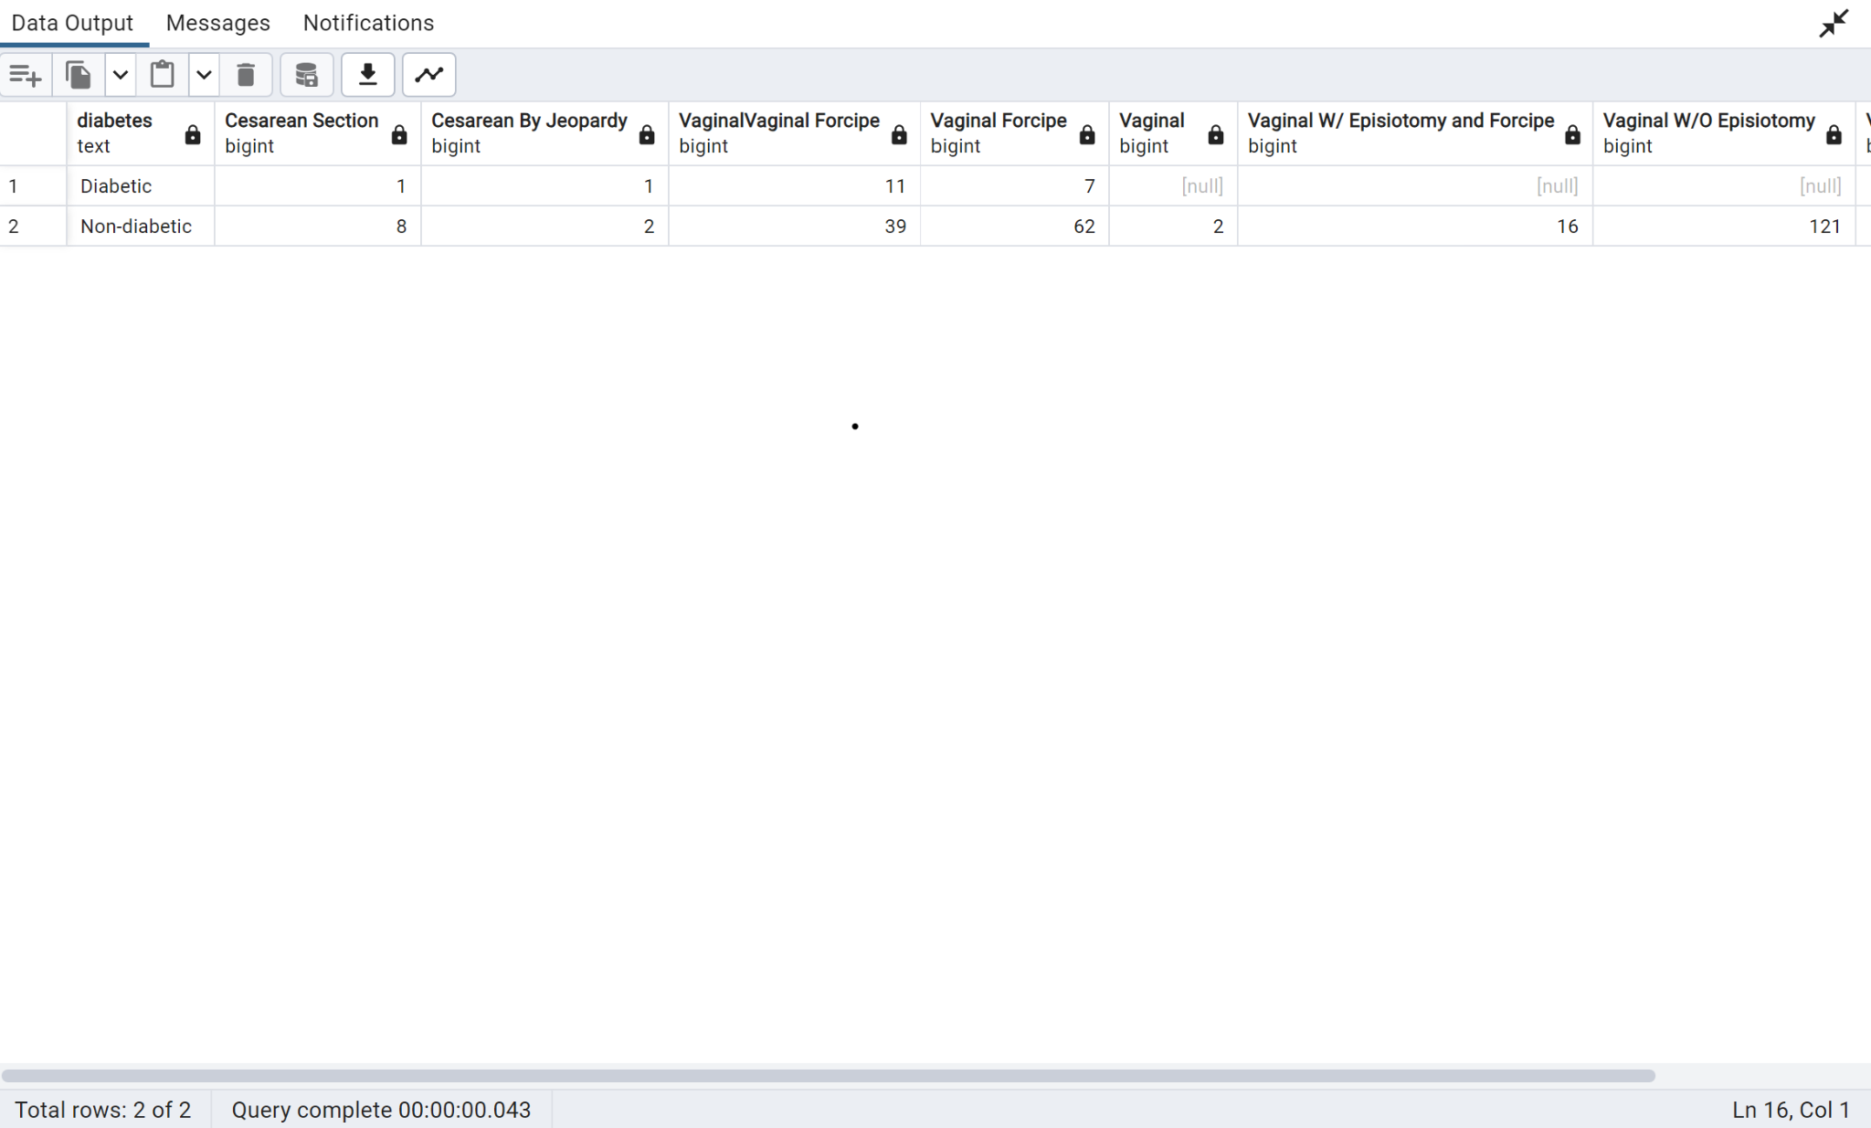

---------------------------------------------------------------------------------------------------------------

**--17. Display the first and last letter of the column delivery mode and the count of patients in each category.**

select substring(delivery_mode,1,1)||substring(reverse(delivery_mode),1,1),count(caseid) from public.hospitalization_labor

group by 1;

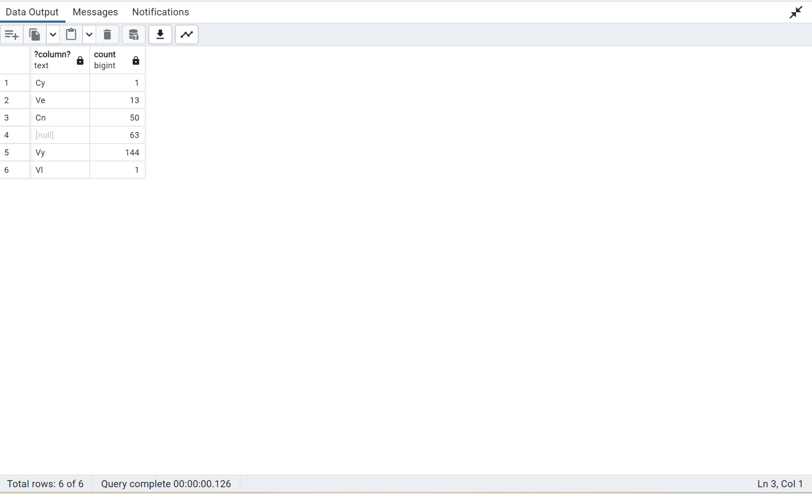

---------------------------------------------------------------------------------------------------------------

**--18. Assuming the alcohol content of fermented alcohol is 10% and distilled is 40%. How many patients are considered high risk alcohol consumers?**

With GetAlchohol as

(

select

case when alcohol_preference =’0’ then alcohol_quantity_milliliters*.4

when alcohol_preference=’1’ then alcohol_quantity_milliliters*.1 else 0 end as AlcUnits,

CaseID

from public.fetal_health_risk where alcohol_quantity_milliliters is not null and alcohol_preference is not null

)

Select 'High Risk Patients', Count(Caseid) from GetAlchohol where

AlcUnits/10>35;

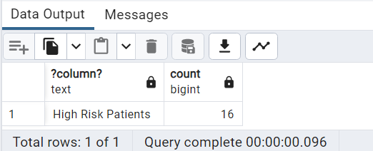

---------------------------------------------------------------------------------------------------------------

**--19. What is the correlation between Visceral fat: Subcutaneous fat and insulin resistance in the 1st trimester for every patient?**

with fatratio as

(

select (sum(periumbilical_visceral_fat+preperitoneal_visceral_fat))/

(sum(periumbilical_subcutanous_fat+preperitoneal_subcutaneous_fat)) ViscSubcutaneous,

max(first_tri_fasting_blood_glucose) fastingglucose,

maternal_fat_assmt.caseid patid

from public.maternal_fat_assmt, public.maternal_labs

where

maternal_labs.caseid=maternal_fat_assmt.caseid and

periumbilical_visceral_fat is not null and preperitoneal_visceral_fat is not null

and periumbilical_subcutanous_fat is not null and preperitoneal_subcutaneous_fat is not null

and first_tri_fasting_blood_glucose is not null

group by 3

)

select corr(ViscSubcutaneous,fastingglucose) from fatratio;

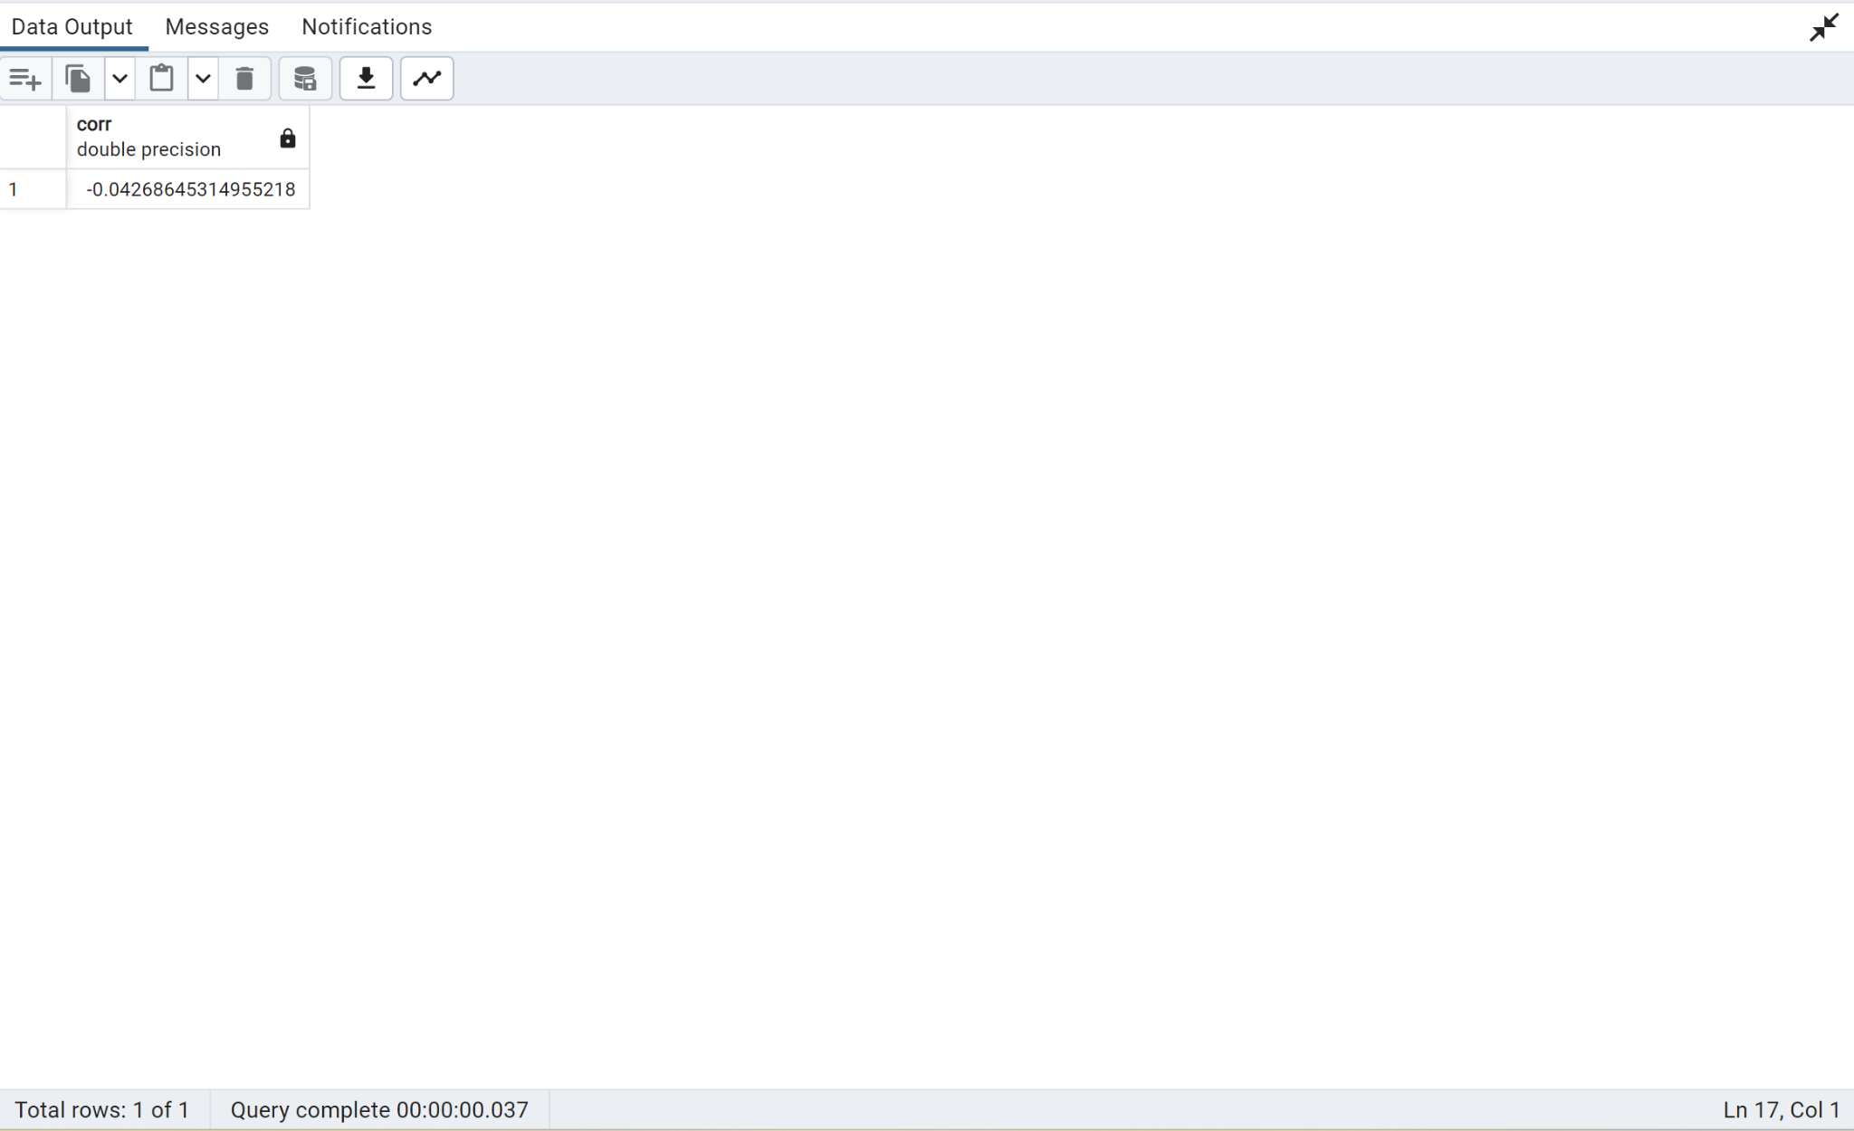

---------------------------------------------------------------------------------------------------------------

**--20. What is the average APGAR score for patients with a body fat % of over 40.**

with FatBF as

(

select 495 / (1.29579 - 0.35004 * (LOG10((maternal_waist_circumference + maternal_hip_circumference - maternal_neck_circumference)))

+ 0.22100 * (LOG10(height_at_inclusion*100))) -450 BFPercent , maternal_fat_assmt.caseid PatID

FROM public.patient_history

JOIN public.maternal_fat_assmt ON patient_history.caseid = maternal_fat_assmt.caseid

where maternal_waist_circumference is not null and

maternal_hip_circumference is not null and

maternal_neck_circumference is not null and

height_at_inclusion is not null and periumbilical_visceral_fat is not null and preperitoneal_visceral_fat is not null

)

select avg(apgar_5th_min)APGAR from FatBF, hospitalization_labor

where FatBF.PatID=hospitalization_labor.caseid and

BFPercent>40;

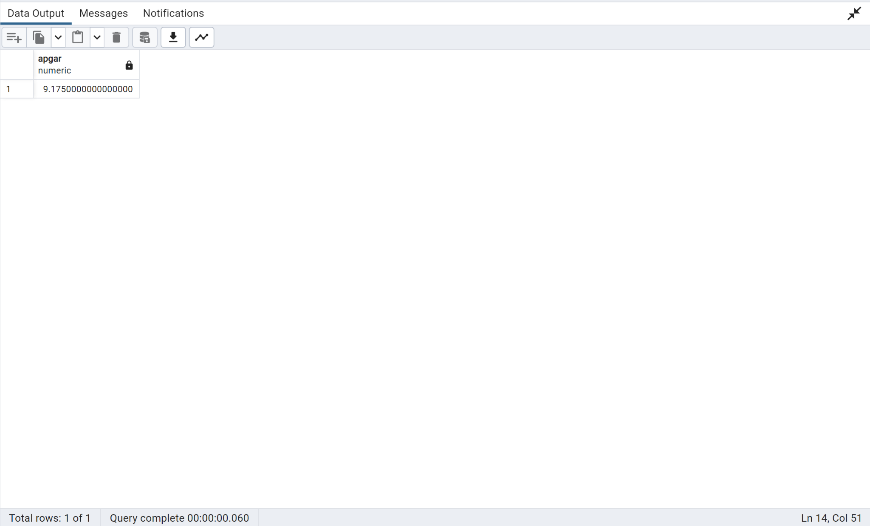

---------------------------------------------------------------------------------------------------------------

**--21. Write a function to get comma-separated values of patient details. (Use a maximum of 6 columns from different tables)**

CREATE OR REPLACE FUNCTION getPatientDet(_patid int)

RETURNS TABLE(caseid int,current_bmi numeric,hospital_systolic_blood_pressure numeric,

periumbilical_total_fat numeric,fruits int) AS

$$

BEGIN

RETURN QUERY

select

pat.caseid,

pat.current_bmi,

hosp.hospital_systolic_blood_pressure,

fat.periumbilical_total_fat,

nutr.caseid

from public.patient_history pat

join public.maternal_fat_assmt fat on

pat.caseid=fat.caseid

join public.hospitalization_labor hosp

on hosp.caseid=fat.caseid

join public.pregnancy_nutrition nutr

on hosp.caseid=nutr.caseid

and pat.caseid = _patid;

END

$$

LANGUAGE plpgsql;

SELECT getPatientDet(237);

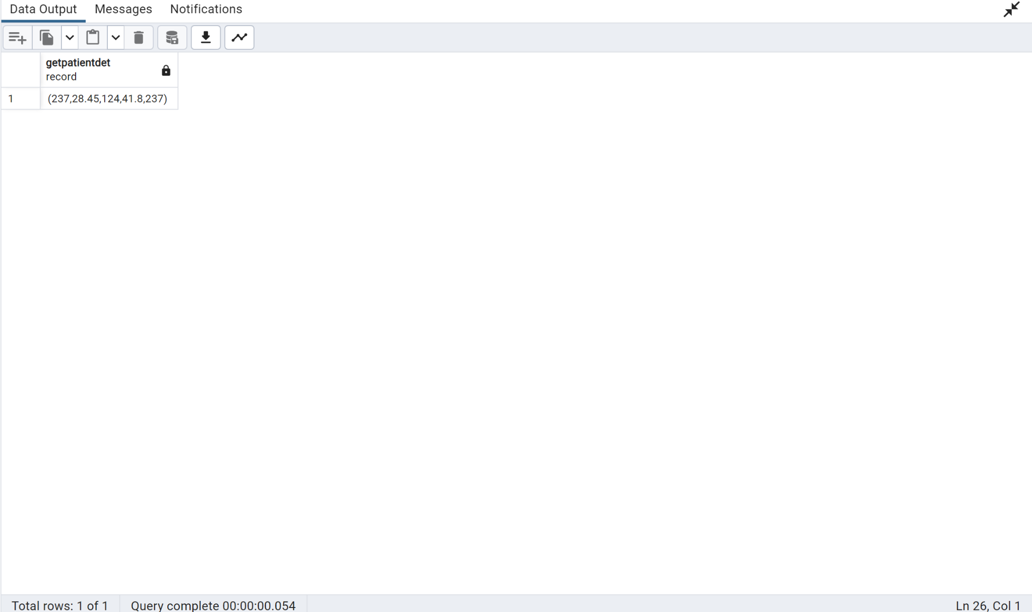

---------------------------------------------------------------------------------------------------------------

**--22. How many patients with high risk drinking habits have Gestational Diabetes?**

With GetAlchohol as

(

select

case when alcohol_preference =’0’ then alcohol_quantity_milliliters*.4

when alcohol_preference=’1’ then alcohol_quantity_milliliters*.1 else 0 end as AlcUnits,

CaseID, gestational_diabetes_mellitus

from public.fetal_health_risk where alcohol_quantity_milliliters is not null and alcohol_preference is not null

)

Select 'All High Risk Patients', Count(Caseid) from GetAlchohol where

AlcUnits/10>35

union all

Select 'High Risk Alcohol GDM Patients', Count(Caseid) from GetAlchohol where

AlcUnits/10>35 and gestational_diabetes_mellitus=1;

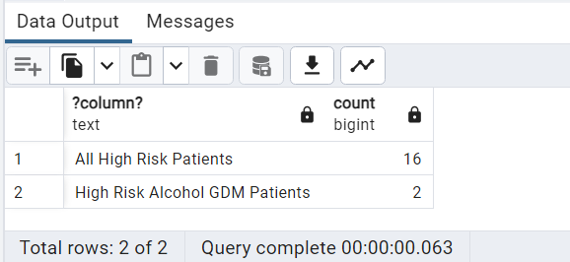

---------------------------------------------------------------------------------------------------------------

**--23. Assuming any pregnancy less than 34 weeks is pre-term, what is the average thickness of total fat(subcutaneous and visceral) in patients with pre-term births?**

select avg(periumbilical_subcutanous_fat+periumbilical_visceral_fat+preperitoneal_subcutaneous_fat+preperitoneal_visceral_fat)

from public.hospitalization_labor,public.maternal_fat_assmt

where

hospitalization_labor.caseid=maternal_fat_assmt.caseid and

gestational_age_at_birth<34;

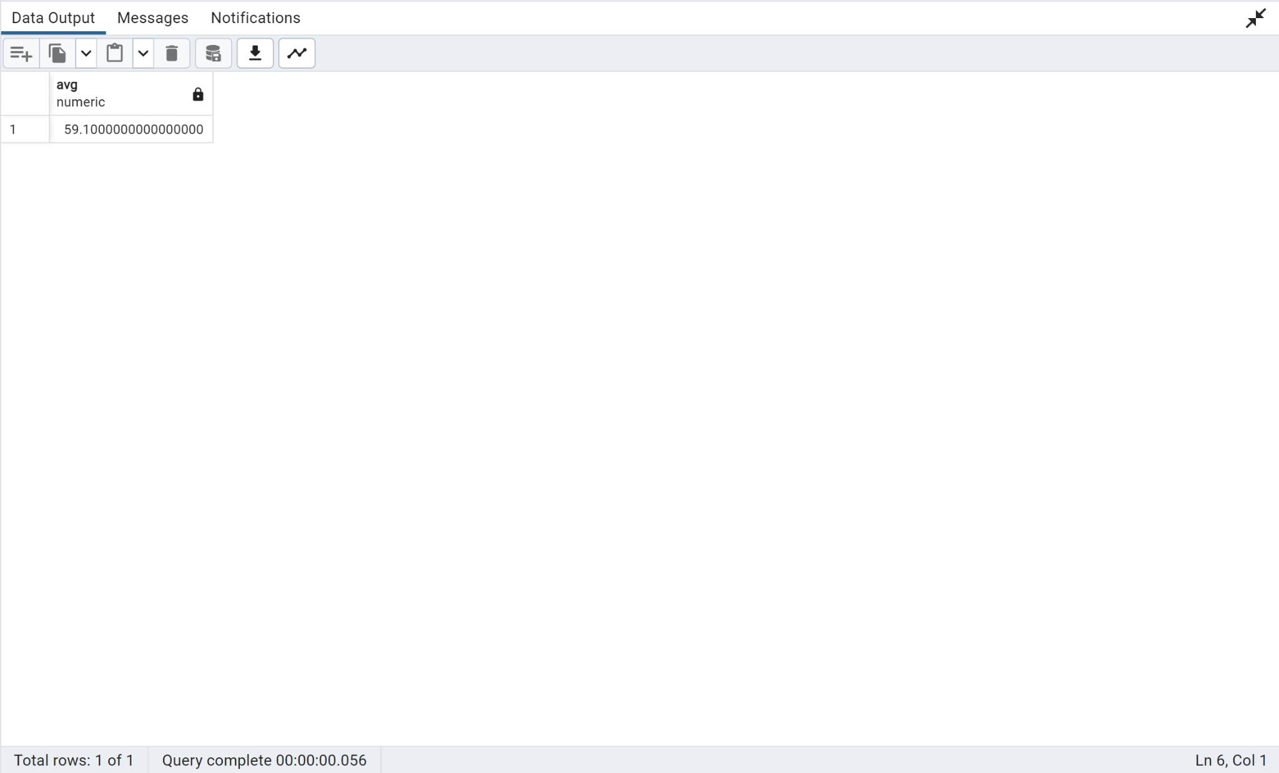

---------------------------------------------------------------------------------------------------------------

**--24. Group the patients into 4 categories of total periumblical fat and show the count of patients in each category**

with PatientTotalFat as

(

select periumbilical_total_fat::int TotalFat, caseid PID from public.maternal_fat_assmt

where periumbilical_total_fat is not null

group by 1,2

)

select width_bucket(TotalFat,0,80,4) as FatCategory, int4range(min(TotalFat),max(TotalFat),'[]') as range,

count(PID) as NumPatients from PatientTotalFat

group by 1

order by 1;

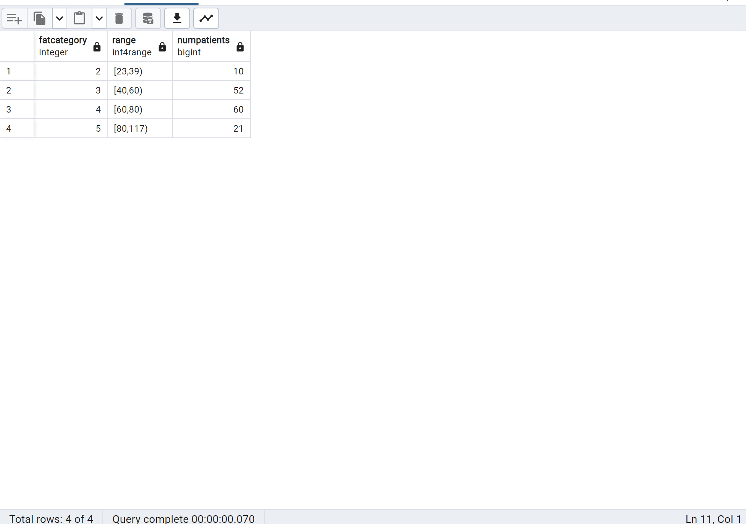

---------------------------------------------------------------------------------------------------------------

**--25. Write a query to get the list of patients whose Ultrasound test values and fasting blood glucose are null.**

select distinct maternal_labs.caseid from public.maternal_fat_assmt, public.maternal_labs

where

maternal_fat_assmt.caseid=maternal_labs.caseid and

first_tri_fasting_blood_glucose is null and

periumbilical_subcutanous_fat is null and

periumbilical_visceral_fat is null and

periumbilical_total_fat is null and

preperitoneal_subcutaneous_fat is null and

preperitoneal_visceral_fat is null;

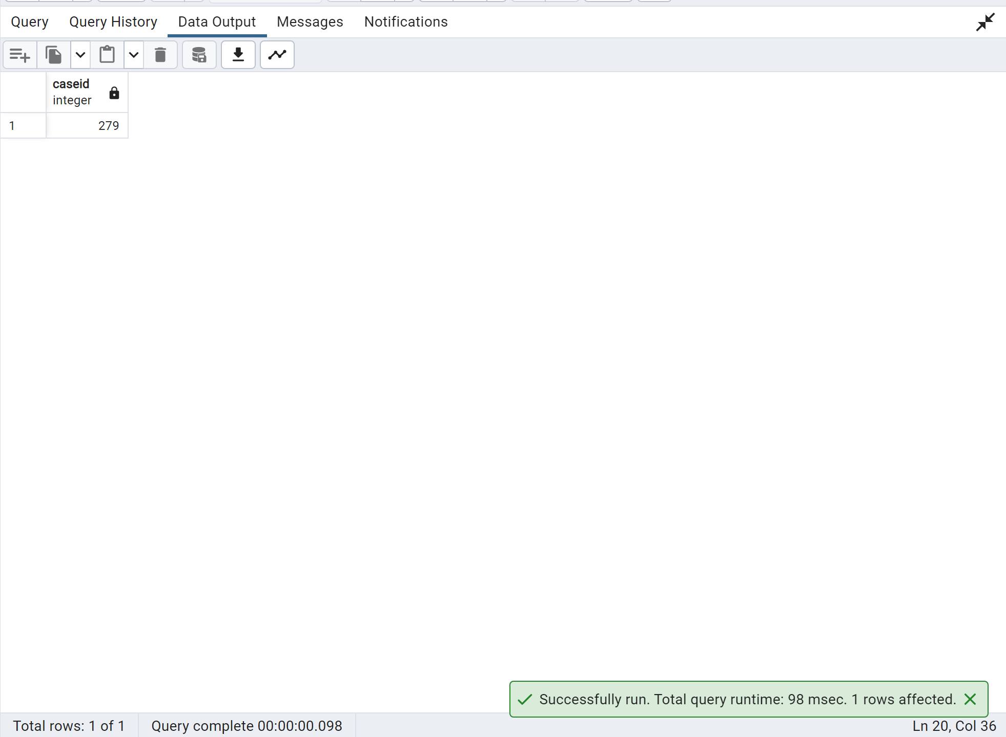

---------------------------------------------------------------------------------------------------------------

**--26. Create a stored procedure to make user ids for the given starting sequence id.**

CREATE OR REPLACE PROCEDURE patient_userid(_caseid int, INOUT val refcursor)

LANGUAGE plpgsql

AS $BODY$

BEGIN

OPEN val FOR

SELECT generate_series(_caseid, _caseid + 10) AS caseid;

END

$BODY$;

CALL patient_userid(2,'ref');

FETCH ALL IN "ref";

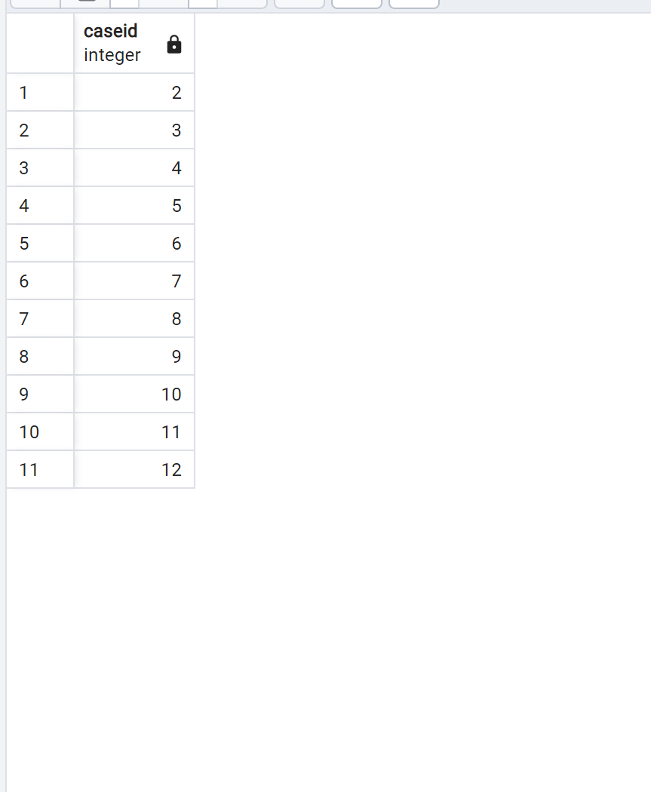

---------------------------------------------------------------------------------------------------------------

**--27. What is average thickness of total fat(subcutaneaous and visceral) in patients with preeclampsia?**

select avg(periumbilical_subcutanous_fat+periumbilical_visceral_fat+preperitoneal_subcutaneous_fat+preperitoneal_visceral_fat)

from public.hospitalization_labor,public.maternal_fat_assmt

where

hospitalization_labor.caseid=maternal_fat_assmt.caseid and

preeclampsia_record_pregnancy=1;

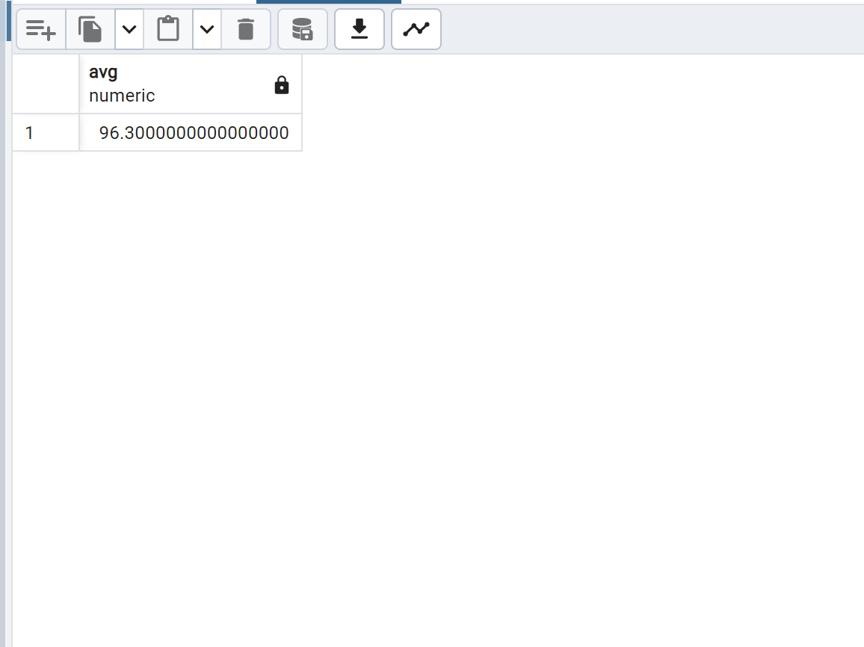

**--Alternate Query--**

with cte as

(select M.caseid,avg(M.periumbilical_subcutanous_fat+M.periumbilical_visceral_fat+

M.preperitoneal_subcutaneous_fat+M.preperitoneal_visceral_fat) as total_fat,

H.preeclampsia_record_pregnancy

from hospitalization_labor as H join maternal_fat_assmt as M

on

H.caseid=M.caseid

group by 1,3)

select corr(total_fat,preeclampsia_record_pregnancy) from cte where preeclampsia_record_pregnancy=1;

---------------------------------------------------------------------------------------------------------------

**--28. What is the correlation between total fat(subcutaneaous and visceral) and patients with preeclampsia?**

with TotalFat as

(

select avg(periumbilical_subcutanous_fat+periumbilical_visceral_fat+preperitoneal_subcutaneous_fat+preperitoneal_visceral_fat) TotalThickness,

maternal_fat_assmt.caseid patid, preeclampsia_record_pregnancy

from public.hospitalization_labor,public.maternal_fat_assmt

where

hospitalization_labor.caseid=maternal_fat_assmt.caseid

group by 2,3

)

select corr(TotalThickness,preeclampsia_record_pregnancy) from TotalFat;

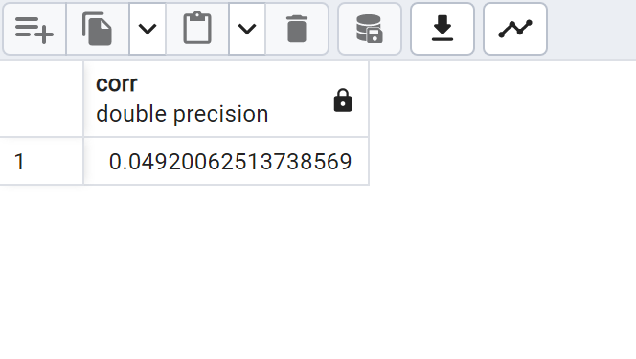

---------------------------------------------------------------------------------------------------------------

--29. Write a query to produce a multiplication table using a recursive view.

WITH RECURSIVE MultiplicationTable AS (

SELECT 9 AS multiplicand, 1 AS multiplier, 9 AS product

UNION ALL

SELECT

multiplicand,

multiplier + 1,

multiplicand * (multiplier + 1) AS product

FROM

MultiplicationTable

WHERE

multiplier < 10

);

SELECT * FROM MultiplicationTable;

---------------------------------------------------------------------------------------------------------------

--30. Use windows functions to get the patient with the highest fasting blood glucose in trimester 3

with HighGlucose as

(

select caseid PatientID, rank() over (order by third_tri_fasting_blood_glucose desc) glucoserank

from public.maternal_labs

where third_tri_fasting_blood_glucose is not null

)

select * from HighGlucose where glucoserank=1;

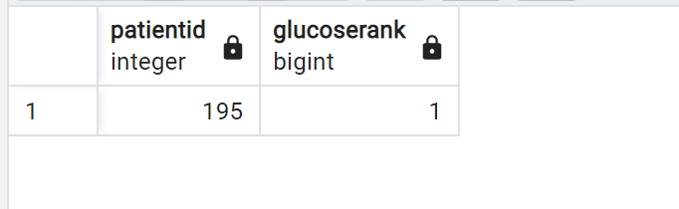

---------------------------------------------------------------------------------------------------------------

--31. Create a trigger to raise notice and prevent deletion of the view created in question 50

create view fetalhealth as

select * from public.fetal_health_risk;

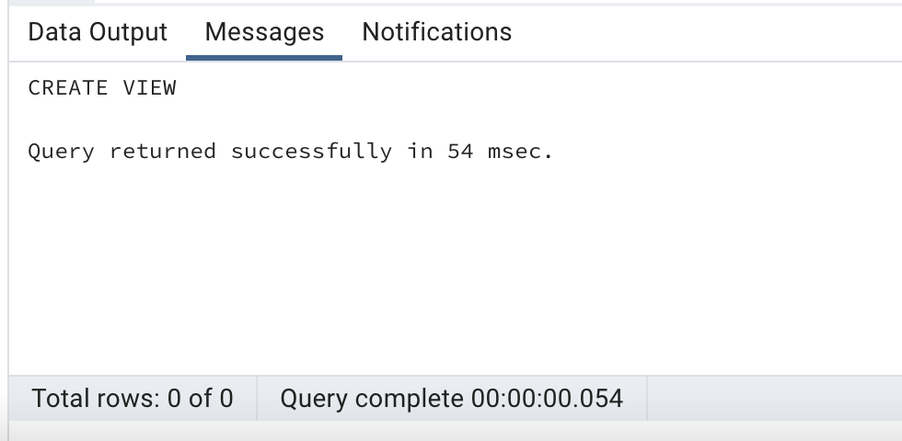

---------------------------------------------------

create or replace function deletefetalrisk()returns trigger as $DonotDelete$

begin

if (TG_OP = 'DELETE') then

Raise exception 'YOU ARE NOT ALLOWED TO DELETE';

end if;

return null;

end;

$DonotDelete$ language plpgsql;

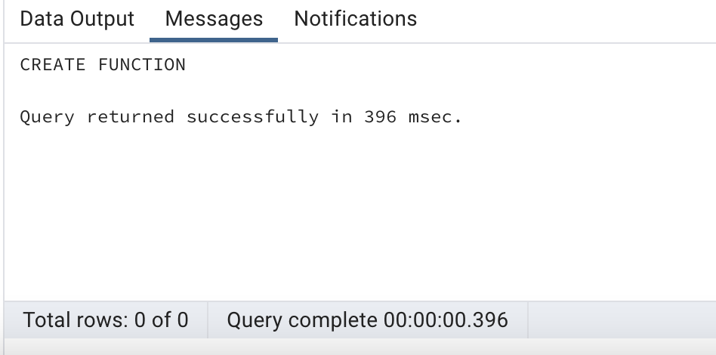

----trigger---

create trigger DonotDelete

instead of delete on fetalhealth

for each row

execute function deletefetalrisk();

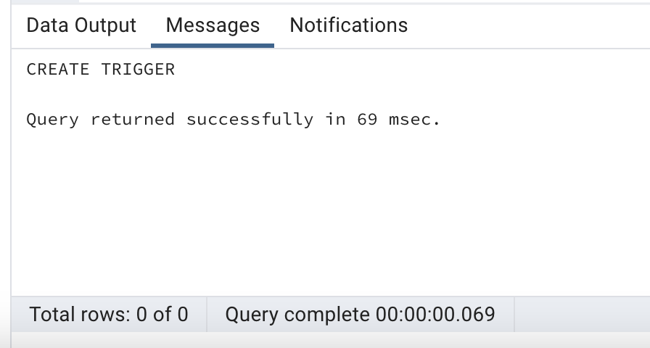

-------------------

delete from fetalhealth;

---------------------------------------------------------------------------------------------------------------

--32. Create a view without using any schema or table and check the created view using a select statement.

Create or Replace View NoTabView

as

(

Select 1 Col1, 2 Col2, 3 Col3

);

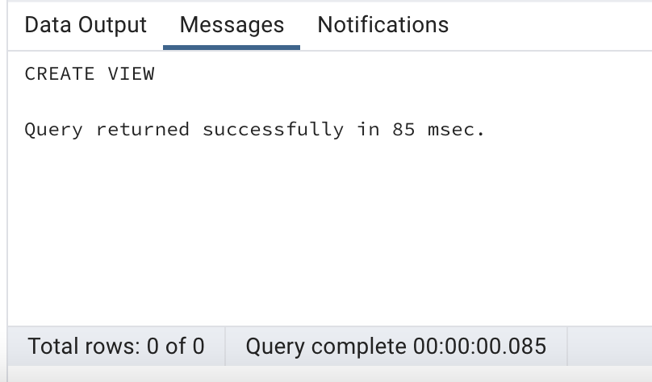

select * from NoTabView;

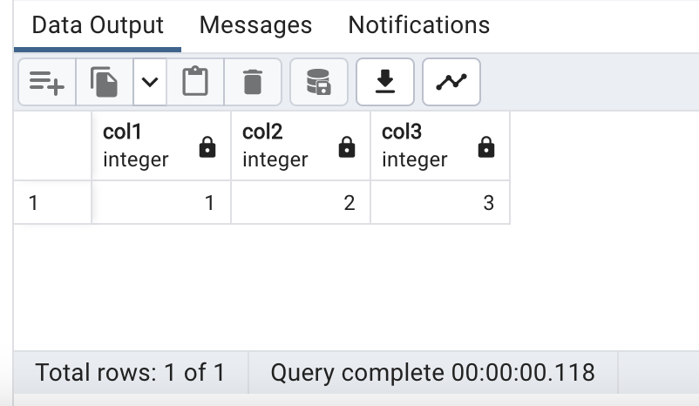

---------------------------------------------------------------------------------------------------------------

--33. Get the number of patients who used every type of drug using the windows function.

SELECT drugs_preference,

sum(COUNT(*)) over (Partition by drugs_preference) NumberDrugUsers

FROM

public.fetal_health_risk

GROUP BY 1;

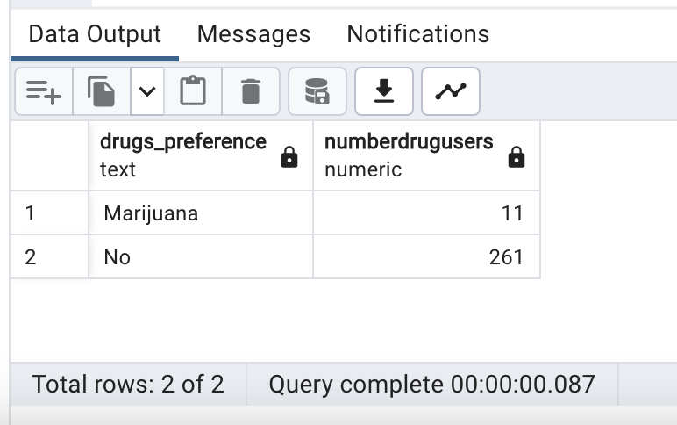

---------------------------------------------------------------------------------------------------------------

--34. Write a query to get patients who satisfy these conditions: Low hematrocit, low hemaglobin or low fasting blood glucose in the 1st tri.

--use the string agg function to show how many conditions are satisfied by each patient"

With Conditions as

(

select caseid, 'Low Hemaglobin' as PatientCondition from

public.maternal_labs

where first_trimester_hemoglobin<11.5

group by caseid,PatientCondition

Union All

select caseid, 'Low hematrocit' as PatientCondition from

public.maternal_labs

where first_trimester_hematocrit<29

group by caseid,PatientCondition

Union All

select caseid, 'Low Blood Glucose' as PatientCondition from

public.maternal_labs

where first_tri_fasting_blood_glucose<70

group by caseid,PatientCondition

)

select caseid, string_agg(PatientCondition,' & ') as PatientCondition from Conditions group by 1;

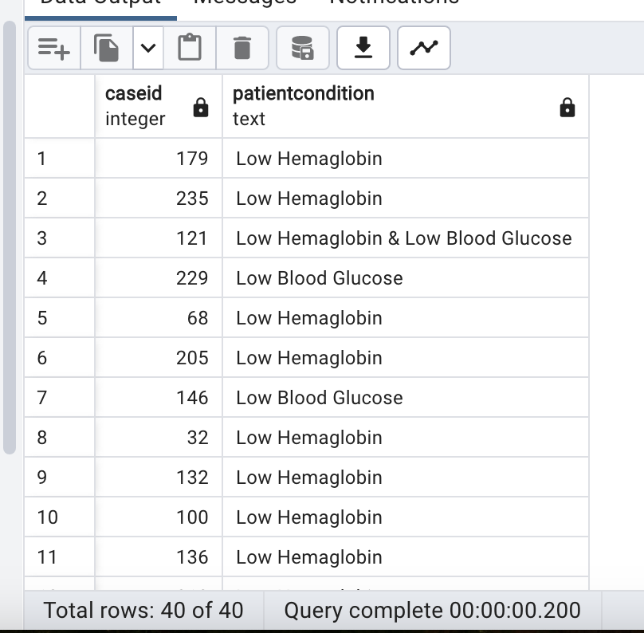

---------------------------------------------------------------------------------------------------------------

--35. What % of all patients with high fasting glucose don't consume breakfast?

with Nobreakfast as

(

select count(maternal_labs.caseid) PatientNoBreakF

from public.pregnancy_nutrition,public.maternal_labs

where

pregnancy_nutrition.caseid=maternal_labs.caseid and

breakfast_meal=0 and first_tri_fasting_blood_glucose>100

),

HighGlucose as

(

select count(caseid) PatientHighG

from public.maternal_labs

where first_tri_fasting_blood_glucose>100

)

select round(sum(PatientNoBreakF)/sum(PatientHighG),2)*100 HighGlucose_NoBreakfast from HighGlucose,Nobreakfast;

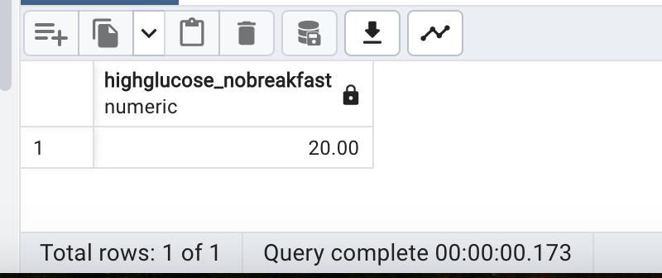

---------------------------------------------------------------------------------------------------------------

--36. Write a trigger that calls a function, for checking new rows inserted for

-- caseids not null and all color ethnicity values are in title case "

create or replace function checking_space_case() returns trigger as $tgr_insert$

begin

if new.caseid is null then

raise exception 'cannot be null ';

end if;

if initcap(new.color_ethnicity) <> new.color_ethnicity then

raise exception 'Please check Title case';

end if;

if substring(new.color_ethnicity,' ') is not null then

raise exception 'cannot have spaces ';

end if;

return new;

end;

$tgr_insert$ language plpgsql;

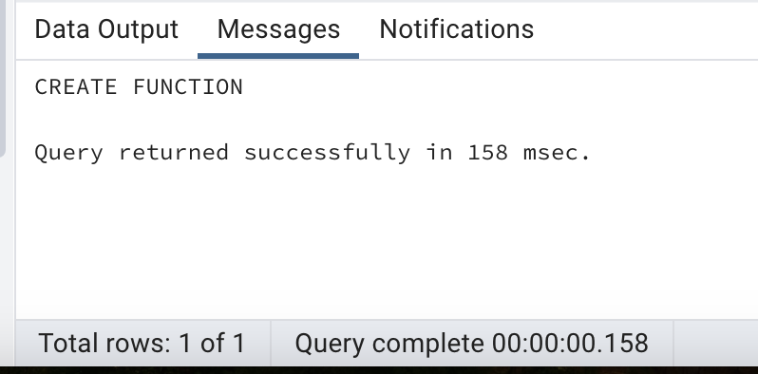

----trigger---

CREATE TRIGGER tgr_insert

BEFORE INSERT ON public.patient_history

FOR EACH ROW

EXECUTE function checking_space_case();

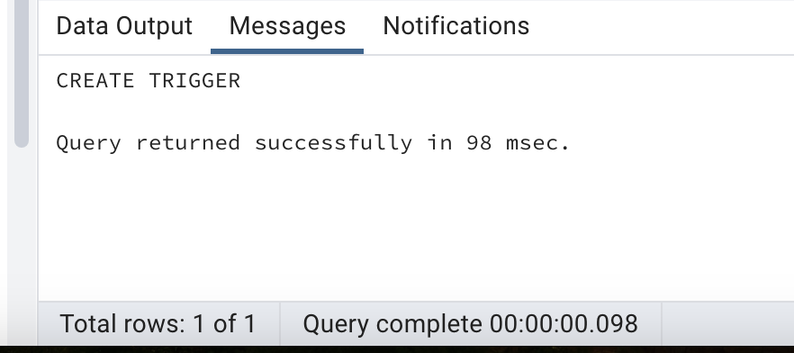

------------------------------------------

INSERT INTO public.patient_history (caseid,color_ethnicity)

VALUES(null,'abcD');

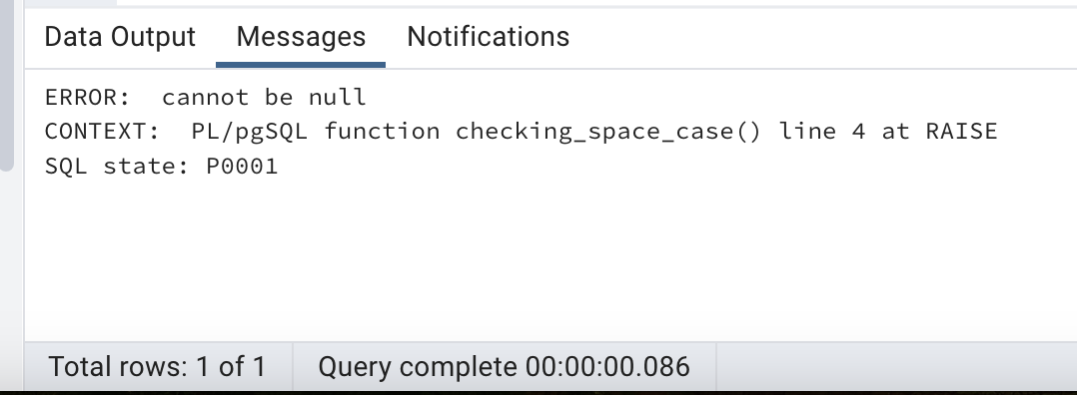

---------------------------------------------------------------------------------------------------------------

--37. Display the mean, standard deviation and variance of all prepregnant weight in the patient history table

select 'Median Weight',avg(prepregnant_weight) from public.patient_history

union

select 'Std DEV Weight',stddev_pop(prepregnant_weight) from public.patient_history

union

select 'Variance Weight',var_pop(prepregnant_weight) from public.patient_history;

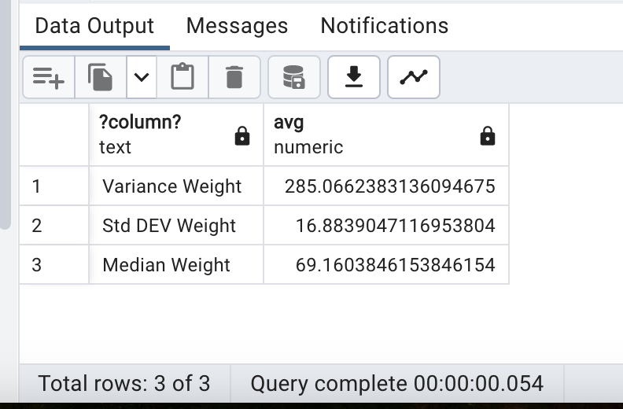

--Alternate Query--

select avg(prepregnant_weight) avgwt, stddev_pop(prepregnant_weight) stdevwt, var_pop(prepregnant_weight) varwt

from patient_history

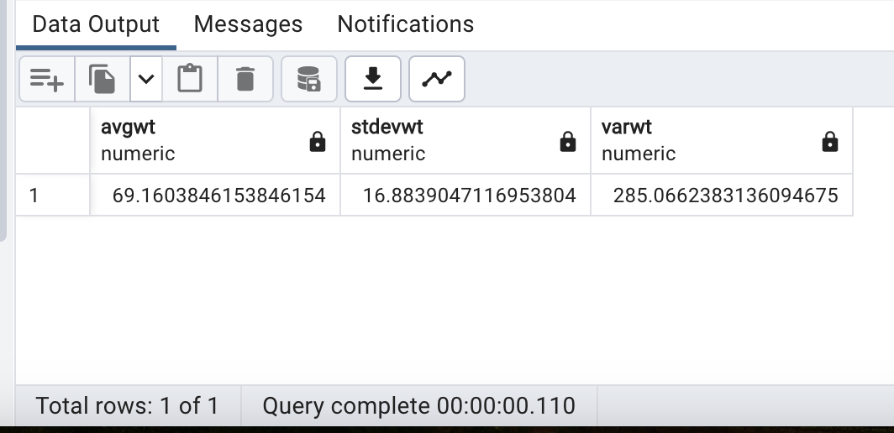

---------------------------------------------------------------------------------------------------------------

--38. Display any 10 random patients along with their age

select caseid,age_years_old from public.patient_history order by random()

limit 10;

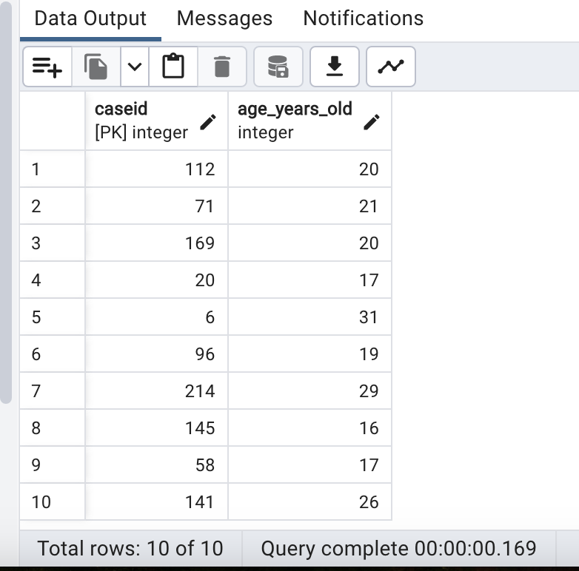

---------------------------------------------------------------------------------------------------------------

--39. What % of all overweight patients consume cookies.

with BMI as

(

select count(patient_history.caseid) CookiesEaten

from public.patient_history,public.pregnancy_nutrition

where

pregnancy_nutrition.caseid=patient_history.caseid and

cookies=1 and current_bmi>30

),

Cookies as

(

select count(patient_history.caseid) OvPatients

from public.patient_history

where

current_bmi>30

)

select round(sum(CookiesEaten)/sum(OvPatients),2)*100 OverweightPatients from BMI,Cookies;

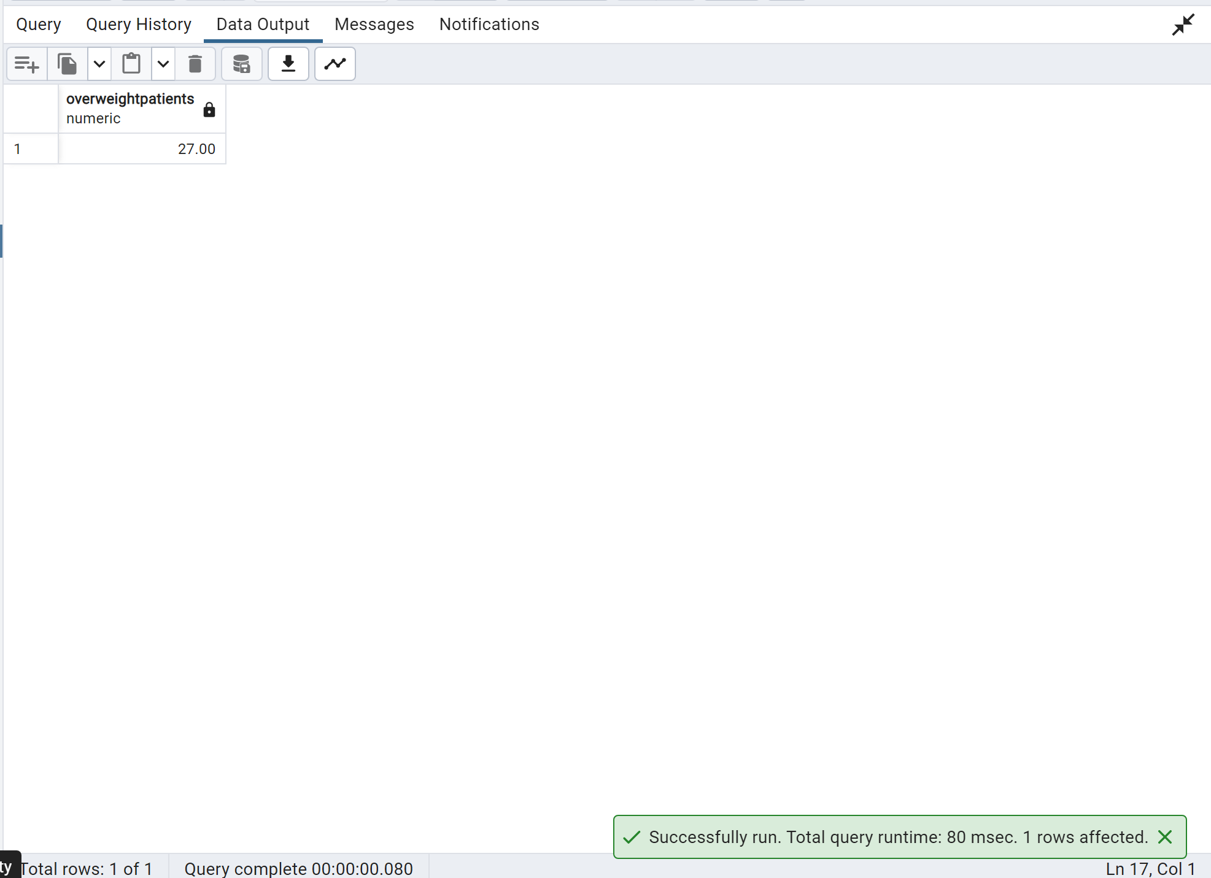

---------------------------------------------------------------------------------------------------------------

--40. What was the average 1-minute APGAR score for newborns who's mothers had had at least 2 prior pregnancies vs mothers who had no prior pregnancies?

select 'More than 2 pregnancies',avg(apgar_1st_min)

from public.prior_gestational_health,

public.hospitalization_labor

where

hospitalization_labor.caseid=prior_gestational_health.caseid and

gestational_age_past_newborn_2 =1 or

gestational_age_past_newborn_3=1 or

gestational_age_past_newborn_4=1

union all

select 'First Pregnancy',avg(apgar_1st_min)

from public.prior_gestational_health,

public.hospitalization_labor

where

hospitalization_labor.caseid=prior_gestational_health.caseid and

gestational_age_past_newborn_1=0 and

gestational_age_past_newborn_2 =0 and

gestational_age_past_newborn_3=0 and

gestational_age_past_newborn_4=0

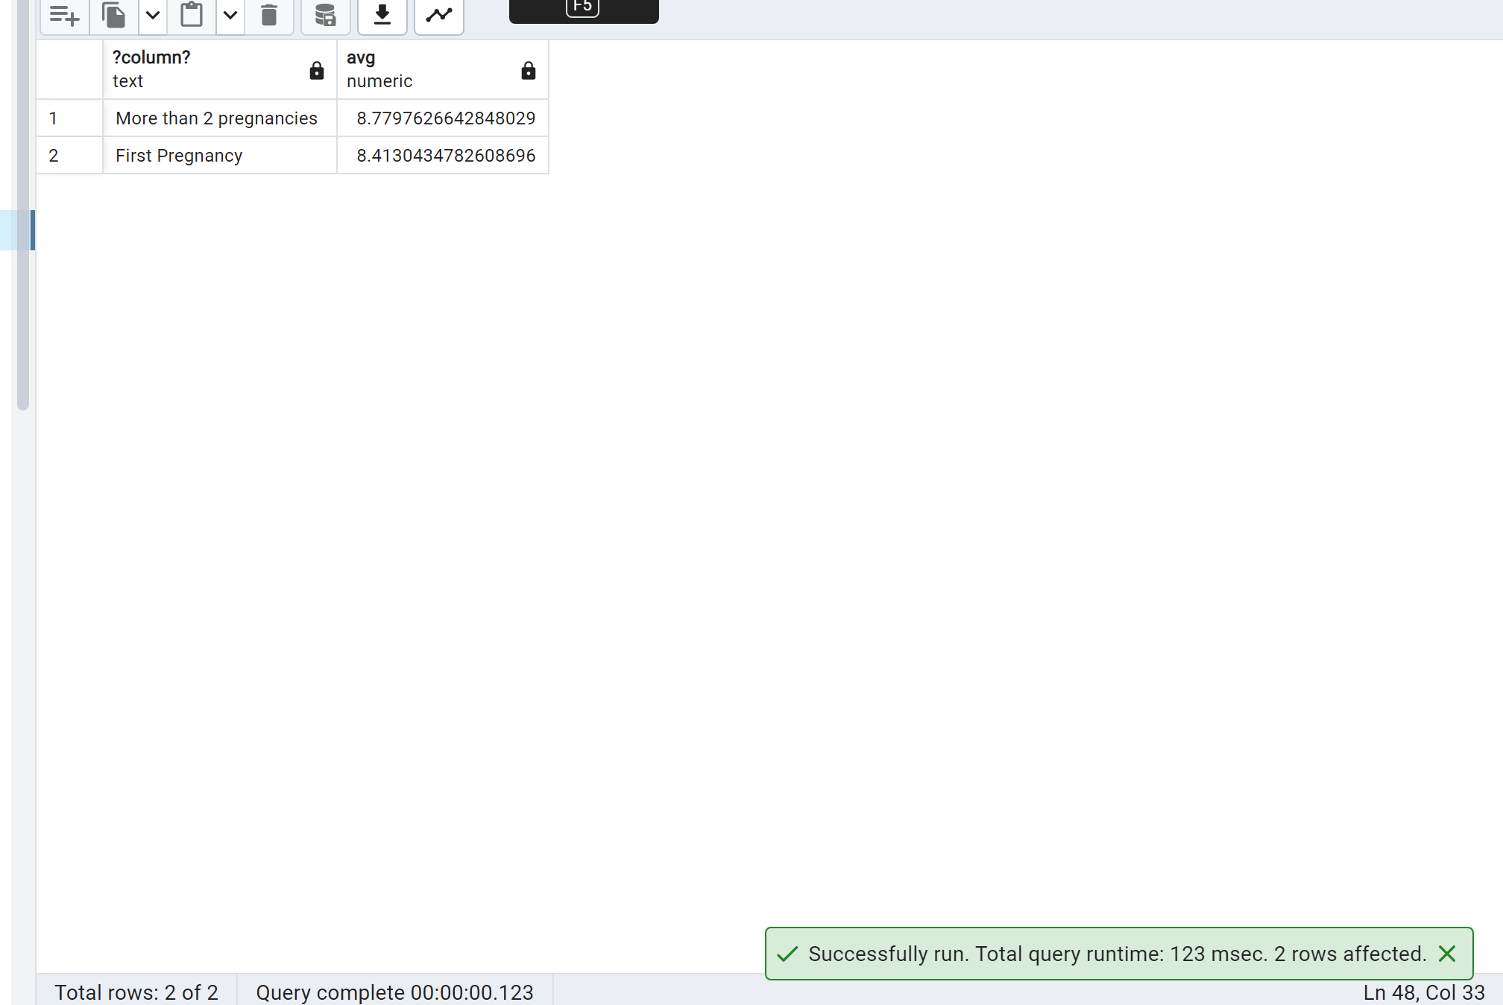

--Alternate Query--

select 'Atleast 2 past pregnancies',avg(apgar_1st_min)

from public.prior_gestational_health,

public.hospitalization_labor

where public.prior_gestational_health.caseid=public.hospitalization_labor.caseid

and past_pregnancies_number>= 2

union all

select 'Atleast no past pregnancies',avg(apgar_1st_min)

from public.prior_gestational_health,

public.hospitalization_labor

where public.prior_gestational_health.caseid=public.hospitalization_labor.caseid

and past_pregnancies_number is null or past_pregnancies_number=0

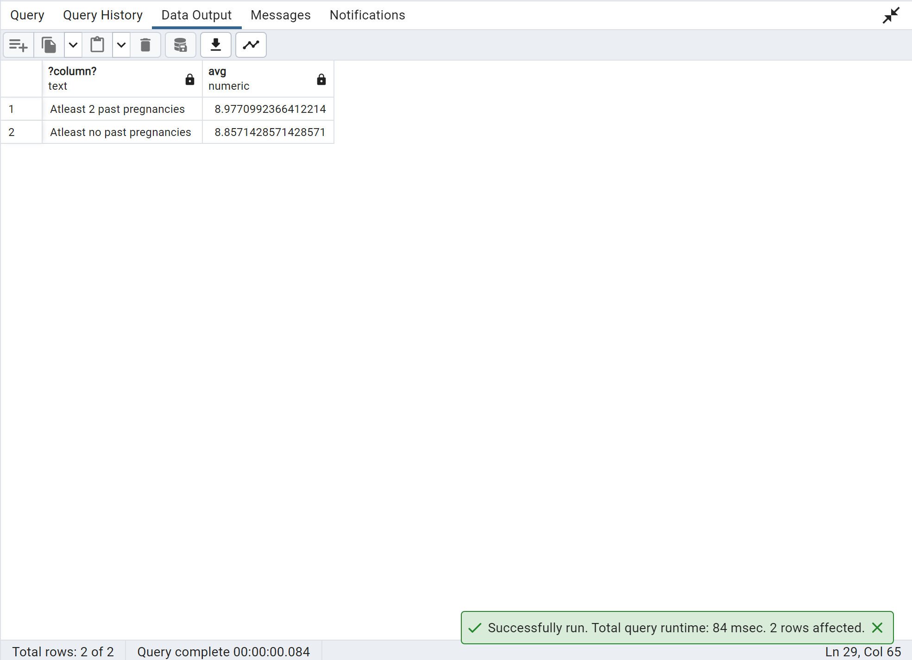

---------------------------------------------------------------------------------------------------------------

--41. Write a query to calculate the moving average of newborn weight in kgs between every 2 pregnancies

--for every patient using windows moving/sliding dynamic average functions.

with Pivottable as

(

select distinct caseid, past_newborn_1_weight Newbornweight from public.prior_gestational_health where past_newborn_1_weight is not null

union all

select distinct caseid, past_newborn_2_weight Newbornweight from public.prior_gestational_health where past_newborn_2_weight is not null

union all

select distinct caseid, past_newborn_3_weight Newbornweight from public.prior_gestational_health where past_newborn_3_weight is not null

union all

select distinct caseid, past_newborn_4_weight Newbornweight from public.prior_gestational_health where past_newborn_4_weight is not null

order by caseid

)

select caseid,

round(avg(Newbornweight) over

(order by caseid rows between 2 preceding and current row )/1000,2) moving_Avg

from Pivottable;

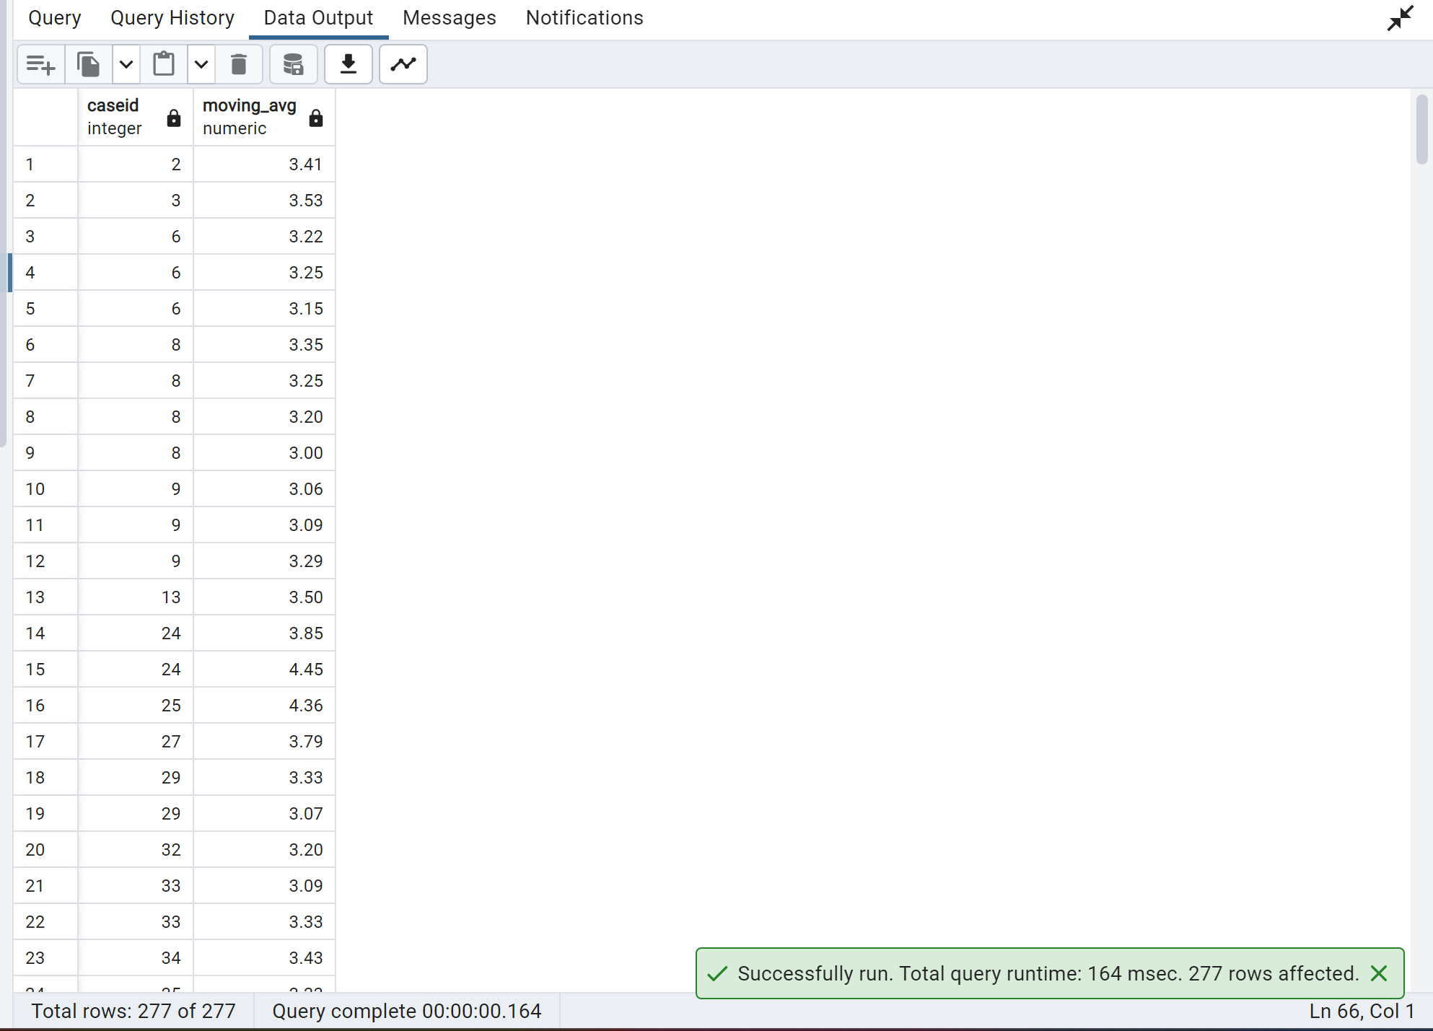

---------------------------------------------------------------------------------------------------------------

**--42. How many past pregnancies has each patient had?**

select caseid, past_pregnancies_number from public.prior_gestational_health

where past_pregnancies_number is not null

group by caseid,past_pregnancies_number

order by caseid;

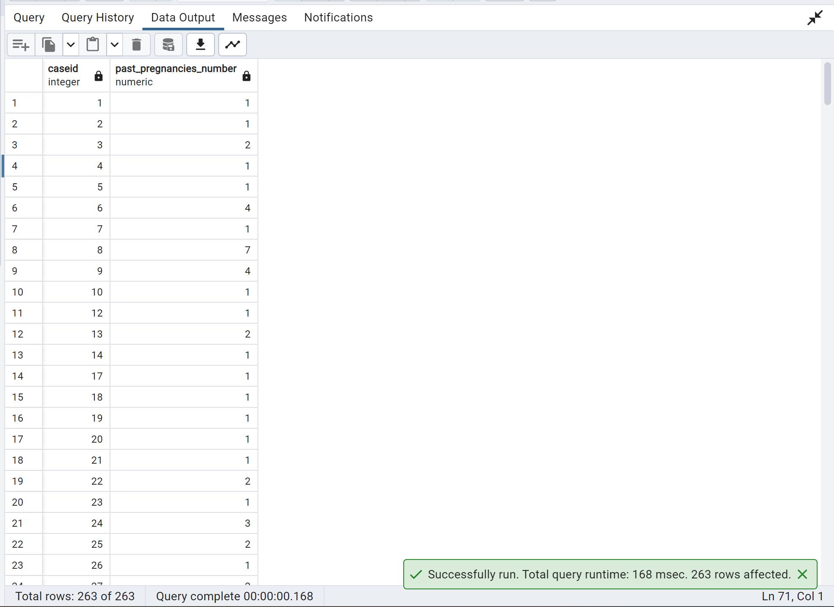

**--Alternate Query--**

select caseid, past_pregnancies_number from public.prior_gestational_health

where past_pregnancies_number is not null

group by caseid,past_pregnancies_number

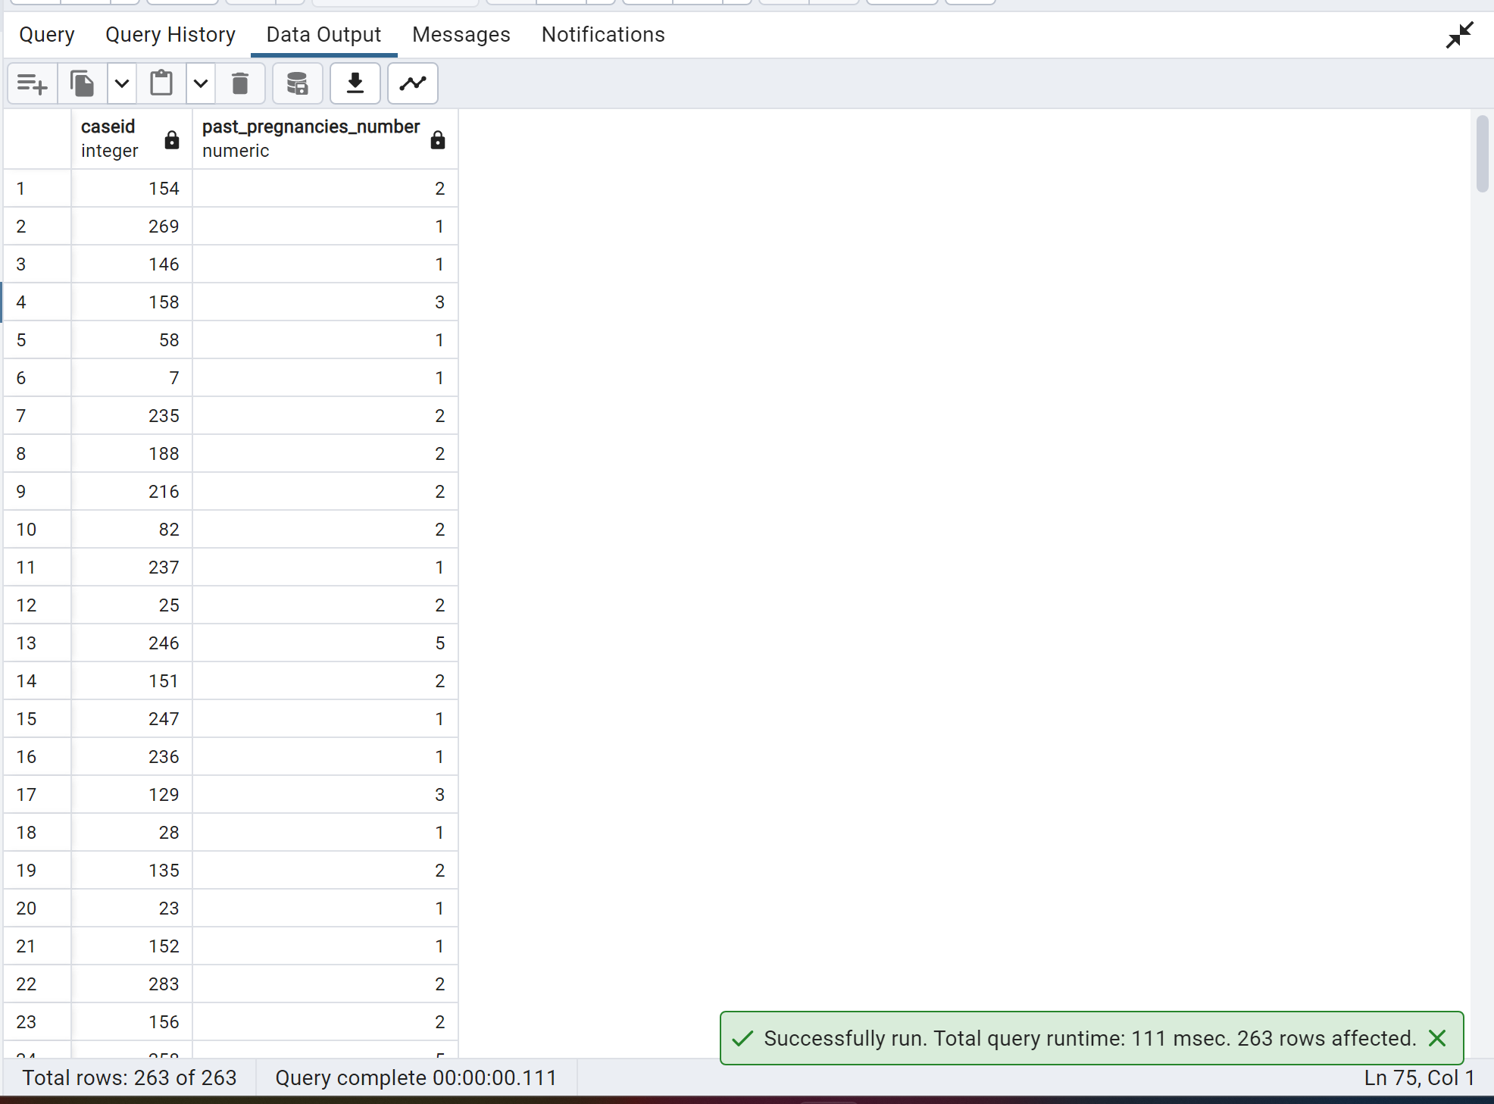

-------------

select caseid, case

when past_pregnancies_number is null then 0

else past_pregnancies_number

end

from public.prior_gestational_health

group by caseid,past_pregnancies_number

order by caseid;

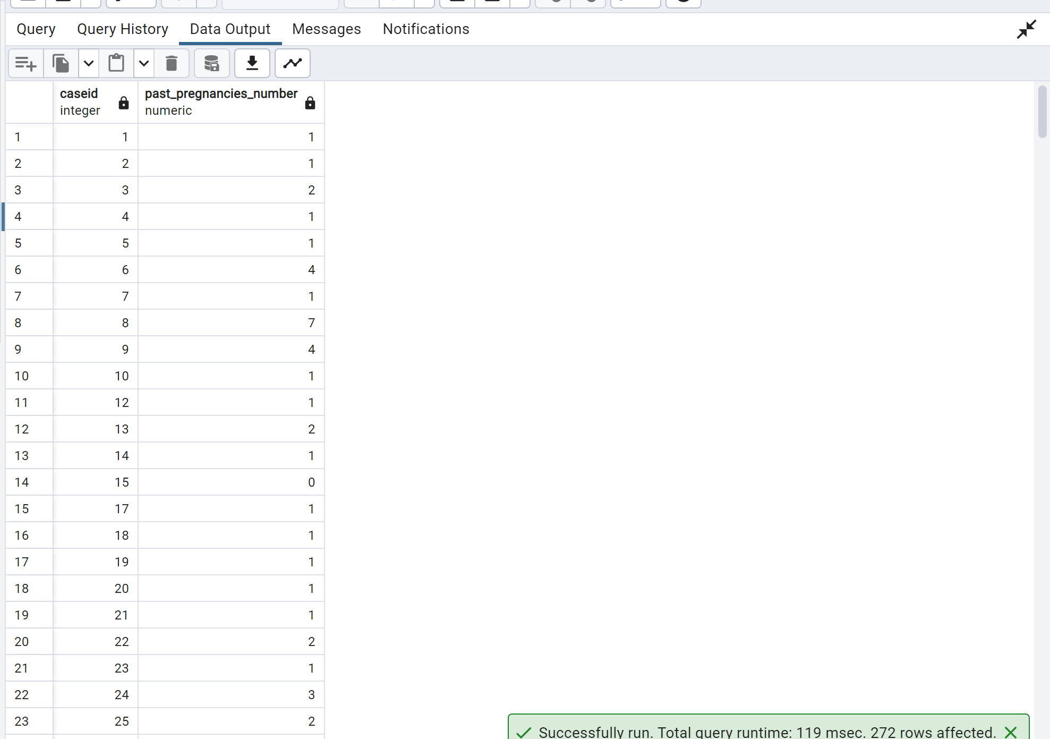

---------------------------------------------------------------------------------------------------------------

**--43. What was the average newborn weight of each patients past pregnancies combined in kgs?**

select round((sum(coalesce(past_newborn_2_weight,0)+coalesce(past_newborn_3_weight,0)+coalesce(past_newborn_4_weight,0))/

sum(coalesce(gestational_age_past_newborn_1,0)+coalesce(gestational_age_past_newborn_2,0)+

coalesce(gestational_age_past_newborn_3,0)+coalesce(gestational_age_past_newborn_4,0)))/1000,2) as AvgNewbornWeight, caseid

from public.prior_gestational_health

where (gestational_age_past_newborn_1 =1 or

gestational_age_past_newborn_2 =1 or

gestational_age_past_newborn_3 =1 or

gestational_age_past_newborn_4 =1) and

(past_newborn_2_weight is not null or

past_newborn_3_weight is not null or

past_newborn_4_weight is not null)

group by caseid;

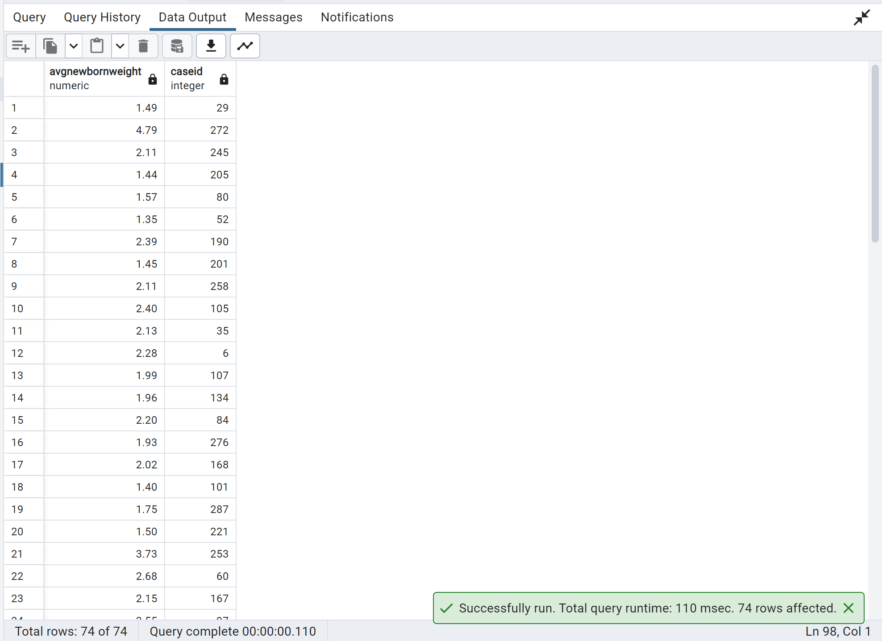

**--Alternate Query--**

select round((avg(coalesce(past_newborn_1_weight,0) + coalesce(past_newborn_2_weight,0)+

coalesce(past_newborn_3_weight,0)+

coalesce(past_newborn_4_weight,0)))/1000,2) as AvgNewbornWeight, caseid

from public.prior_gestational_health

where

(

past_newborn_1_weight is not null or

past_newborn_2_weight is not null or

past_newborn_3_weight is not null or

past_newborn_4_weight is not null)

group by caseid

order by caseid;

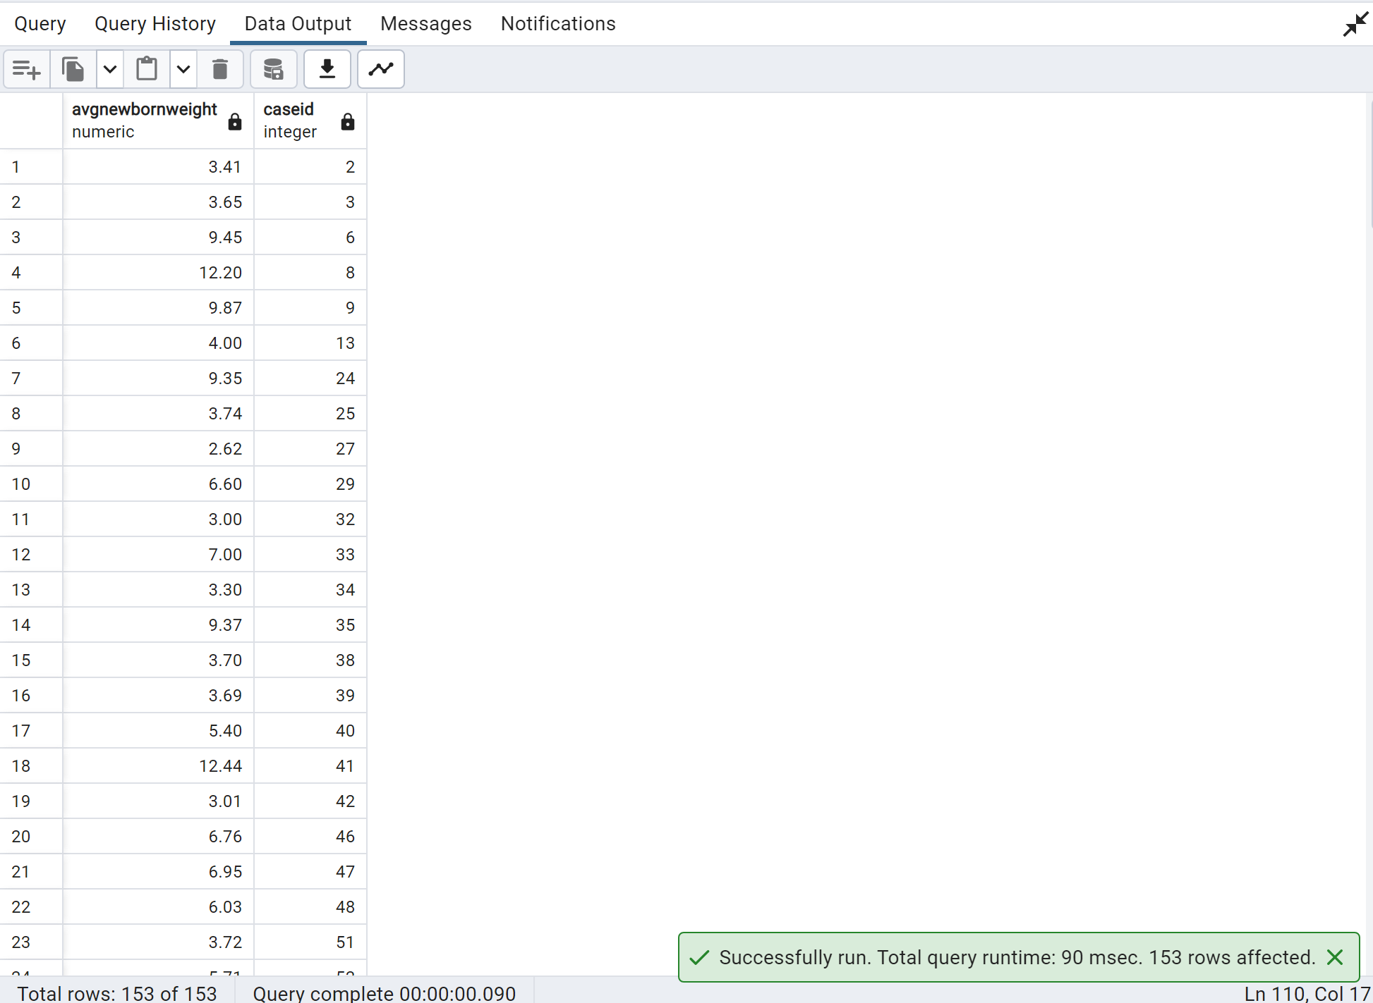

---------------------------------------------------------------------------------------------------------------

**--44. Create a procedure for checking if an ethnicity entered by user exists and return number of records found.**

CREATE OR REPLACE PROCEDURE public.chkrace(

IN _inrace text)

LANGUAGE 'plpgsql'

AS $BODY$

declare raceout bigint;

begin

raceout= (select count(*) from public.patient_history

where color_ethnicity=_inrace);

RAISE notice 'No. Of Records Found: %', raceout;

end;

$BODY$;

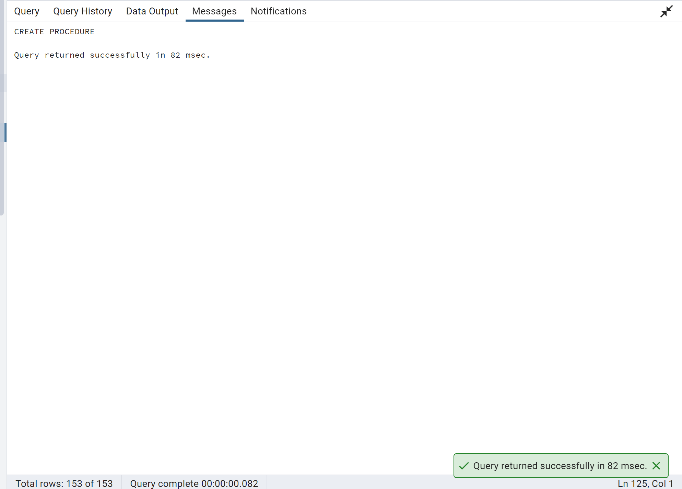

call chkrace('White');

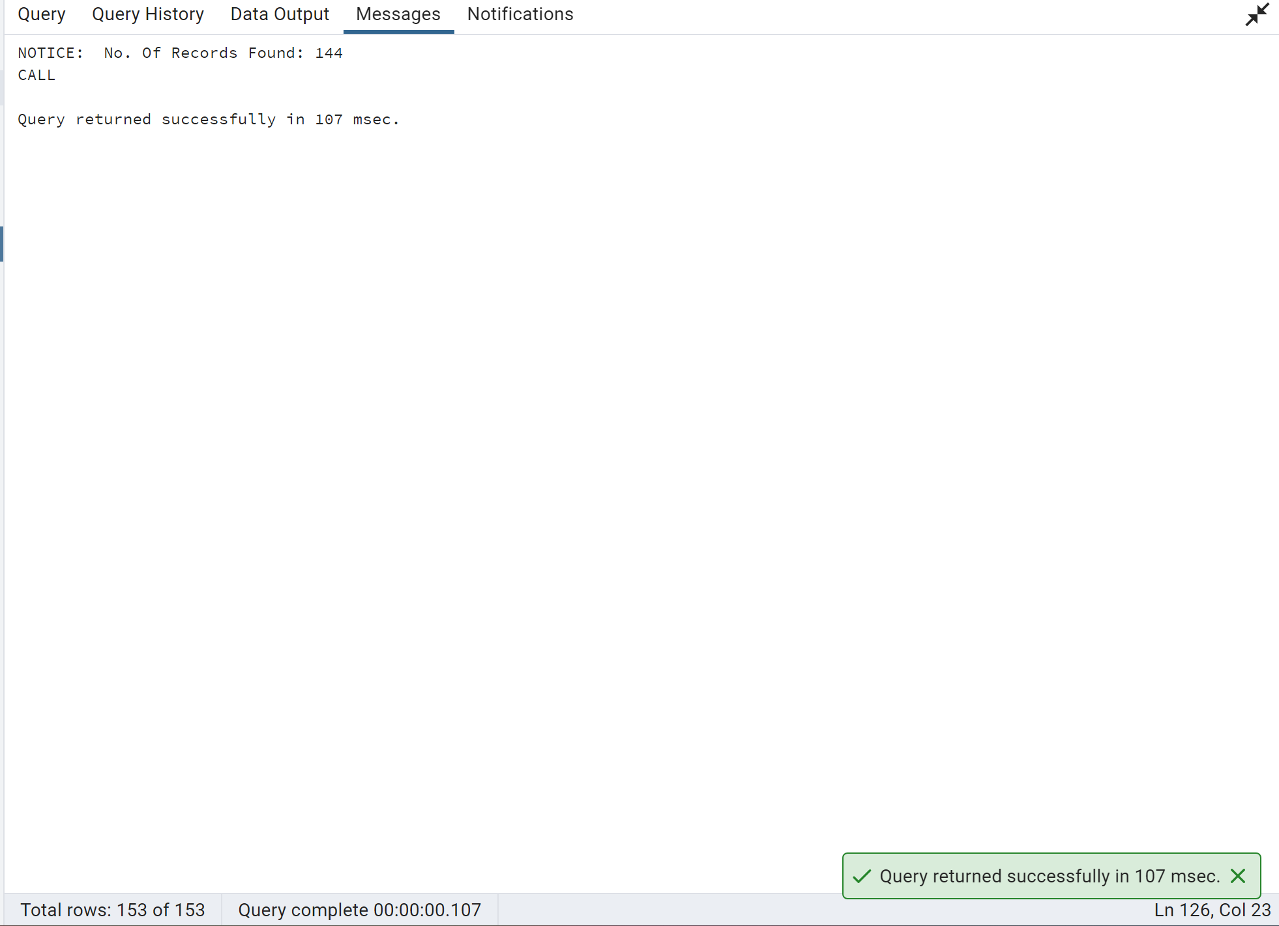

---------------------------------------------------------------------------------------------------------------

**--45. What was the increase in % of risk of preeclampsia in mothers with hypertension recorded in the hospital vs others.**

with Hypertension as

(

select count(*) PreeclampsiaHyper

from public.hospitalization_labor

where

preeclampsia_record_pregnancy=1

and hospital_hypertension =1

),

NoHypertension as

(

select count(*) PreeclampsiaNoHyper

from public.hospitalization_labor

where

preeclampsia_record_pregnancy=1

and hospital_hypertension =0

),

AllPreeclampsia as

(

select count(*) Preeclampsia

from public.hospitalization_labor

where

preeclampsia_record_pregnancy=1

)

select round(((sum(PreeclampsiaHyper)-sum(PreeclampsiaNoHyper))/sum(Preeclampsia))*100,2) from Hypertension,NoHypertension,AllPreeclampsia;

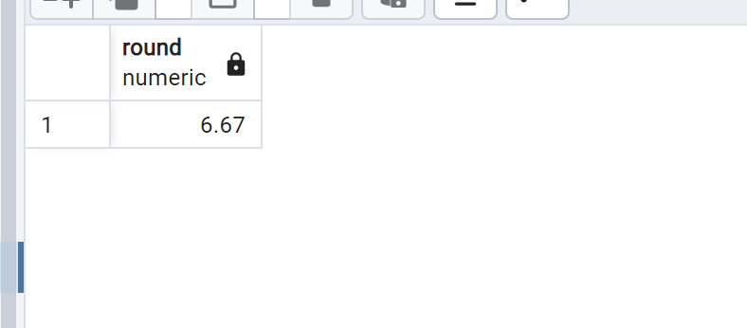

---------------------------------------------------------------------------------------------------------------

**--46. Group the patients into 4 categories of total Visceral fat and show the count of patients in each category that had a C-section**

with PatientViscFat as

(

select (periumbilical_visceral_fat+preperitoneal_visceral_fat)::int VisceralFat,

maternal_fat_assmt.caseid PID

from public.maternal_fat_assmt, public.hospitalization_labor

where maternal_fat_assmt.caseid=hospitalization_labor.caseid

and periumbilical_visceral_fat is not null

and preperitoneal_visceral_fat is not null

and delivery_mode like 'C%'

group by 1,2

)

select width_bucket(VisceralFat,0,80,4) as RiskCat,

int4range(min(VisceralFat),max(VisceralFat),'[]') ViscFat,

count(PID) as NumPatients from PatientViscFat

group by 1

order by 1;

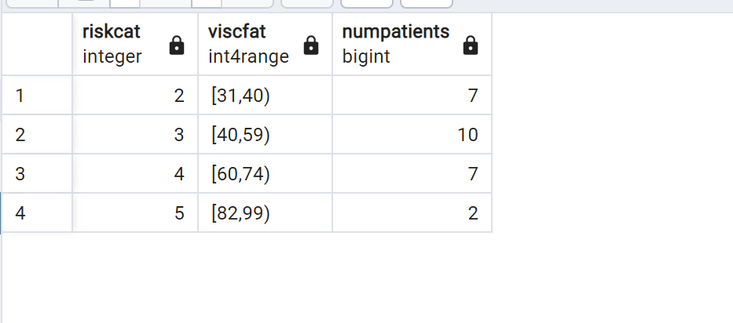

---------------------------------------------------------------------------------------------------------------

**--47. create a function to check if a patient was born in a leap year.**

CREATE OR REPLACE FUNCTION born_leap_year(patient_id int)

RETURNS BOOLEAN AS $$

DECLARE

birth_year int;

age int;

BEGIN

SELECT age_years_old INTO age

FROM public.patient_history

WHERE caseid = patient_id;

birth_year := EXTRACT(YEAR FROM NOW()) - age;

RETURN date_part('day', make_date(birth_year, 3, 1) - '1 day'::interval) = 29;

END

$$ LANGUAGE plpgsql;

SELECT born_leap_year(1);

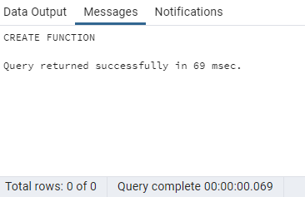

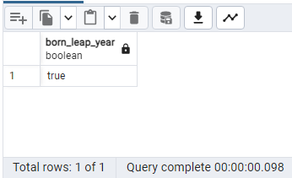

---------------------------------------------------------------------------------------------------------------

**--48. Calculate Mean Arterial pressure for all patients.**

select caseid,

round((hospital_systolic_blood_pressure + (hospital_systolic_blood_pressure - hospital_diastolic_blood_pressure)/3),2) MAP

from

public.hospitalization_labor

where

hospital_systolic_blood_pressure is not null and

hospital_diastolic_blood_pressure is not null;

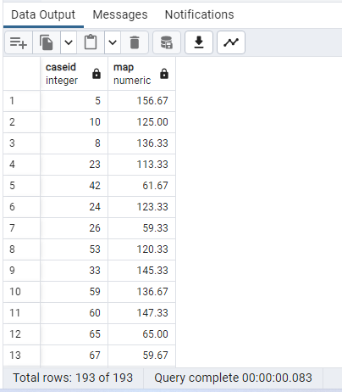

---------------------------------------------------------------------------------------------------------------

**--49. Display all diseases diagnosed during pregnancy, ensure that that output is Title cased**

Select distinct initcap(disease_diagnose_during_pregnancy) from public.hospitalization_labor;

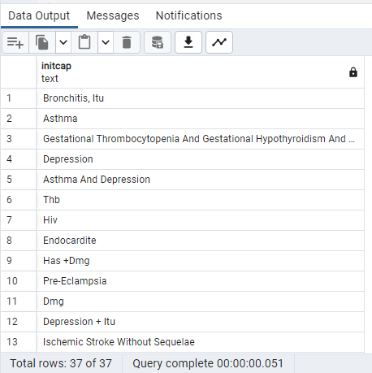

---------------------------------------------------------------------------------------------------------------

**--50. Create a view on the fetal health risk table using the check constraint**

create or replace view fetal_risk

as select caseid,drugs_preference from public.fetal_health_risk with check option;

select * from fetal_risk;

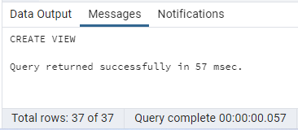

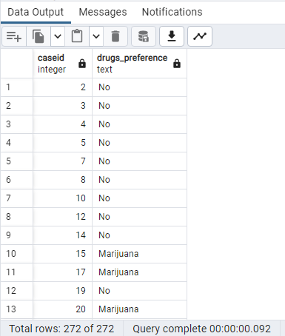

---------------------------------------------------------------------------------------------------------------

**--51. Write a query to get which race has the maximum number of patients with bodyfat>45.**

select color_ethnicity, count(*) from

public.patient_history,public.maternal_fat_assmt

where

patient_history.caseid=maternal_fat_assmt.caseid

and

(495 / (1.29579 - 0.35004 * (LOG10((maternal_waist_circumference + maternal_hip_circumference - maternal_neck_circumference)))

+ 0.22100 * (LOG10(height_at_inclusion*100))) -450)>45

group by 1

order by 2 desc

limit 1;

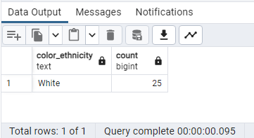

---------------------------------------------------------------------------------------------------------------

**--52. Write a query using the trigger that fires after insert on the labs table if the patient has abnormal fasting glucose values.**

CREATE OR REPLACE FUNCTION Lab_Check() RETURNS TRIGGER AS $$

BEGIN

if (New.first_tri_fasting_blood_glucose>110)then

raise notice 'Blood Glucose high';

end if;

RETURN NULL;

END;

$$ LANGUAGE plpgsql;

Create trigger Lab_tgr

After insert ON public.maternal_labs

for each row Execute function Lab_Check();

insert into public.maternal_labs (caseid, first_tri_fasting_blood_glucose) Values(198,,140);

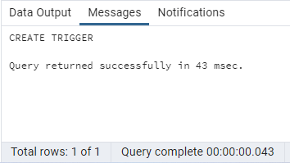

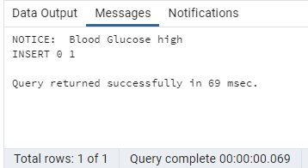

---------------------------------------------------------------------------------------------------------------

**--53. Count patients by first letter of disease treatment during pregnancy.**

SELECT LEFT(treatment_disease_pregnancy,1),COUNT(*)

FROM public.hospitalization_labor

GROUP BY 1

ORDER BY 1;

**--Alternate Query--**

select substring(treatment_disease_pregnancy,1,1) first_letter, count(caseid)

from public.hospitalization_labor

group by first_letter

order by first_letter;

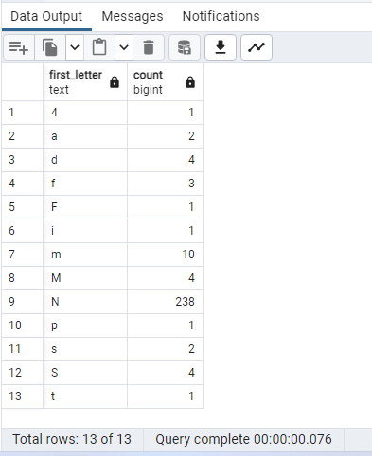

---------------------------------------------------------------------------------------------------------------

**--54. Display Patients With Delivery contains 'Cesarean' and replace it with 'C-'.**

SELECT Caseid,REGEXP_REPLACE(Delivery_mode,'Cesarean','C-') AS NewDeliveryMode

FROM public.hospitalization_labor

WHERE Delivery_mode LIKE 'C%';

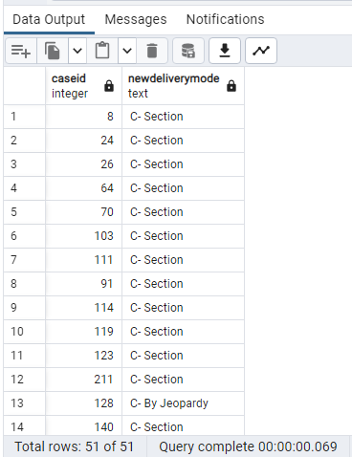

---------------------------------------------------------------------------------------------------------------

**--55. Create any type of trigger on a view containing all blood pressure details.**

Create view blood_pressure_view as

(

Select hospital_systolic_blood_pressure,hospital_diastolic_blood_pressure,hospital_hypertension from public.hospitalization_labor

);

CREATE OR REPLACE FUNCTION Blood_Pressure_view() RETURNS TRIGGER AS $$

BEGIN

if (tg_op='DELETE') then

raise notice 'for delete';

end if;

RETURN NULL;

END;

$$ LANGUAGE plpgsql;

Create trigger tgr_BP_view

instead of delete ON public.Blood_Pressure_view

for each row Execute function Blood_Pressure_view();

Delete from public.Blood_Pressure_view;

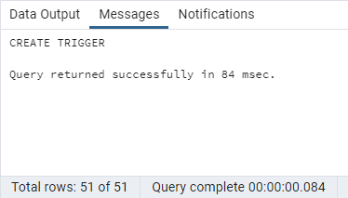

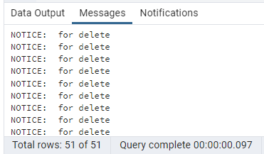

---------------------------------------------------------------------------------------------------------------

**--56. Find all tables where column caseid is present. (Display column position number with respective table also)**

select table_name, column_name,

ordinal_position PositionOfColInTable from information_schema.columns where column_name = 'caseid';

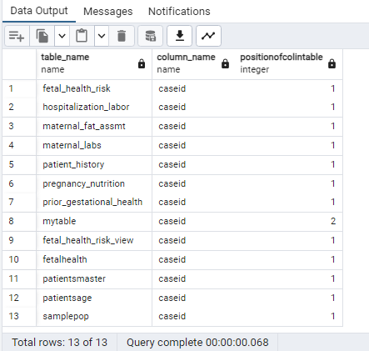

---------------------------------------------------------------------------------------------------------------

**--57. Add 2 datetime column to patient history table. One should just contain todays date, the other should only contain time. The data should be inserted along with the addition of columns, not as a separate command**

alter table public.patient_history

add column casedate date default now();

alter table public.patient_history

add column casetime time default now()::time;

select * from public.patient_history;

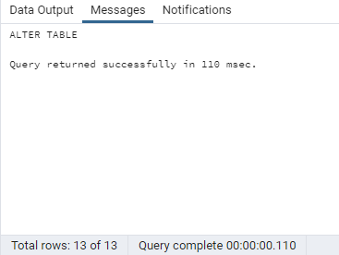

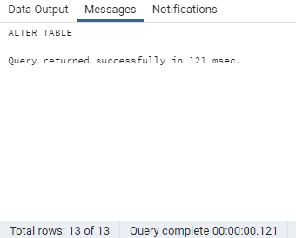

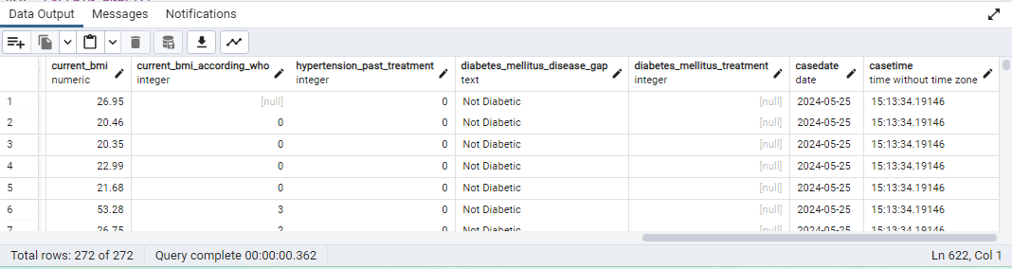

---------------------------------------------------------------------------------------------------------------

**--58. Select the disease treatment mode starting with f and has uox as the 3rd,4th and 5th character and any letters after**

select distinct treatment_disease_pregnancy

from public.hospitalization_labor where treatment_disease_pregnancy like 'f_uox%';

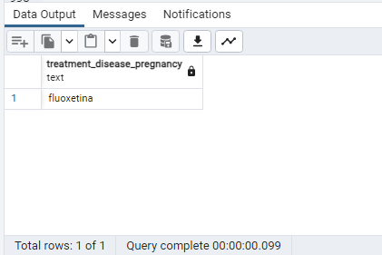

---------------------------------------------------------------------------------------------------------------

**--59. Write a query to update hospitalization table set all values of disease diagnoses to capital letters where disease diagnosis starts with h.**

update public.hospitalization_labor set disease_diagnose_during_pregnancy=upper(disease_diagnose_during_pregnancy)

where (disease_diagnose_during_pregnancy) ilike 'h%';

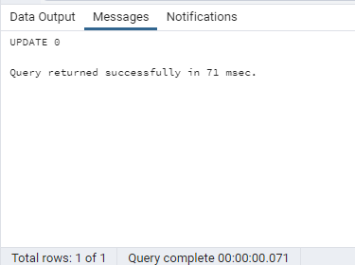

**--Alternate Query--**

update public.hospitalization_labor

set disease_diagnose_during_pregnancy = upper(disease_diagnose_during_pregnancy)

where (disease_diagnose_during_pregnancy) like 'h%';

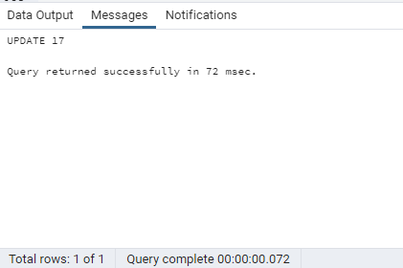

---------------------------------------------------------------------------------------------------------------

**--60. Write a function to query the database for all user defined functions based on a user-specified return type.**

CREATE OR REPLACE FUNCTION public.find_function(_dtype text)

RETURNS TABLE(routine_name text, routine_schema text, return_type text)

LANGUAGE sql

AS $function$

select routine_name, routine_schema, data_type

from information_schema.routines

where specific_schema not in ('pg_catalog', 'information_schema')

and upper(data_type) like upper(_dtype) ||'%'

order by routine_name;

$function$;

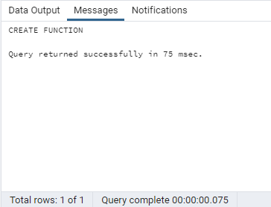

select * from find_function('');

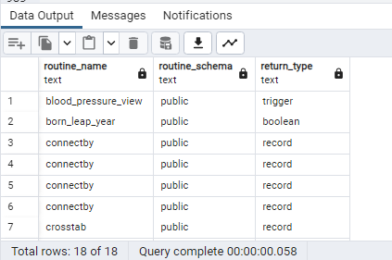

---------------------------------------------------------------------------------------------------------------

-**-61. Create materialized view with no data, to display no patients within each race.**

CREATE MATERIALIZED VIEW patient_gender_count

AS

select color_ethnicity , count(*) from public.patient_history

group by 1

WITH NO DATA;

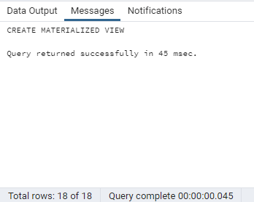

REFRESH MATERIALIZED VIEW patient_gender_count;

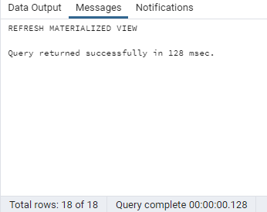

select * from patient_gender_count;

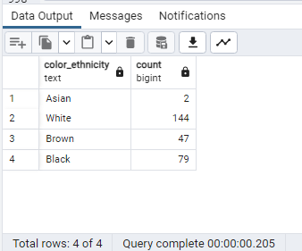

Drop MATERIALIZED VIEW patient_gender_count;

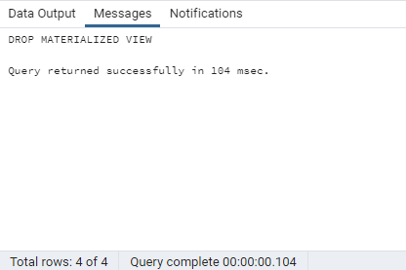

---------------------------------------------------------------------------------------------------------------

**--62. Write a query to create a master Patient table and its child table. Make sure that the child table inherits all the fields from the parent Patient table.**

CREATE TABLE PatientsMaster (

caseid text,

color_ethnicity Int

);

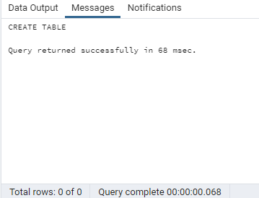

CREATE TABLE PatientsAge (

age_years_old text

) INHERITS (PatientsMaster);

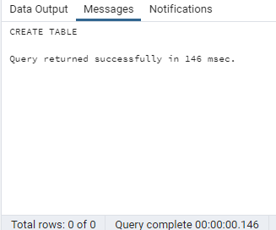

select * from PatientsAge;

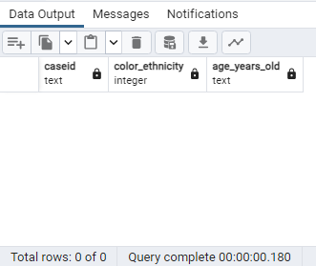

---------------------------------------------------------------------------------------------------------------

**--63. Show every patients fasting blood glucose in the first trimester marker along with physical attributes and labels in a json friendly format**

SELECT row_to_json(combined) FROM

(select patient_history.caseid,age_years_old,height_at_inclusion,current_bmi,first_tri_fasting_blood_glucose

from public.patient_history,public.maternal_labs

where patient_history.caseid=maternal_labs.caseid) combined;

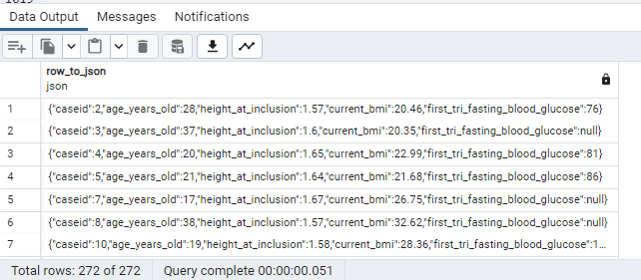

---------------------------------------------------------------------------------------------------------------

**--64. Create an index on any table and use explain analyze to show differences if any.**

CREATE INDEX idx_case ON public.patient_history(caseid);

EXPLAIN ANALYZE SELECT * FROM public.patient_history where caseid=1;

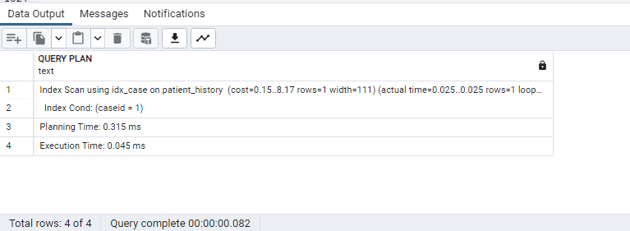

---------------------------------------------------------------------------------------------------------------

**--65. calcuate the number of patients who have chronic diabetes and low HB count**

select count(*) NumCases

from

public.hospitalization_labor, public.maternal_labs

where

hospitalization_labor.caseid=maternal_labs.caseid and

(first_trimester_hemoglobin<11 or

second_trimester_hemoglobin<11 or

third_trimester_hemoglobin<11) and

chronic_diabetes=1;

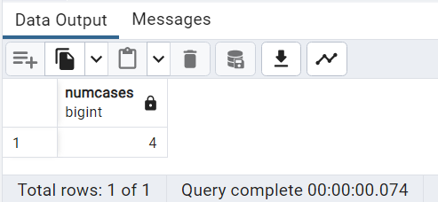

---------------------------------------------------------------------------------------------------------------

**--66. Create a normally distributed list of sample patients and their 3rd tri hemaglobin and hematrocit levels based on the averages in the lab table based on Gaussian distribution.**

Create Table SamplePop as

(

with hematrocit as

(

select avg(third_trimester_hemoglobin) AvgHB, Avg(third_trimester_hematocrit) AvgHCT FROm public.maternal_labs

)

SELECT 'S0'||generate_series(1,10) Caseid, normal_rand(10,AvgHB ,1) as HB,

normal_rand(10, AvgHCT,2) HCT FROM hematrocit ORDER BY 1

);

Select * from SamplePop;

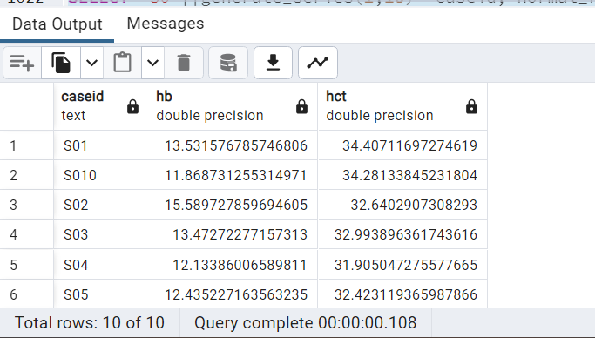

---------------------------------------------------------------------------------------------------------------

**--67. write a query to get the number of patients for each age bin without using the CASE statement.(Bin size - 5)**

with AgeInt as (

select age_years_old::int Age, caseid from public.patient_history

)

select width_bucket(Age,0,100,20) as Agebucket,

int4range(min(Age),max(Age),'[]') as range,

count(caseid) as NumPatients

from AgeInt

group by 1

order by 1;

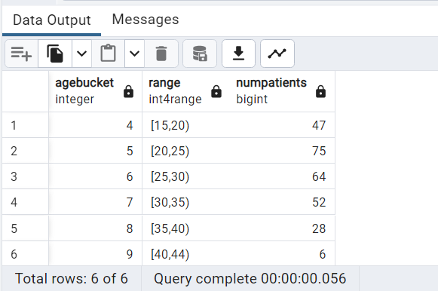

---------------------------------------------------------------------------------------------------------------

**--68. How many patients had a first trimester hematrocit that was higher than their third trimester hematrocit and vice versa.**

select max(First_higher) First_higher,

max(Third_higher) Third_higher from

(

select count(caseid) First_higher, 0 Third_higher from public.maternal_labs

where first_trimester_hematocrit>third_trimester_hematocrit and

first_trimester_hematocrit is not null and third_trimester_hematocrit is not null

union all

select 0 First_higher,count(caseid) Third_higher

from public.maternal_labs

where first_trimester_hematocrit<third_trimester_hematocrit and

first_trimester_hematocrit is not null and third_trimester_hematocrit is not null) Glucosetest;

**--Alternate Query--**

select count(case when first_trimester_hematocrit > third_trimester_hematocrit then 1 else null end) as first_higher_third,

count(case when first_trimester_hematocrit < third_trimester_hematocrit then 1 else null end) as third_higher_first

from maternal_labs;

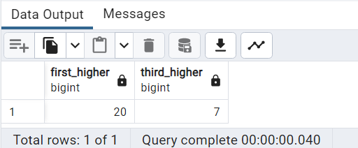

---------------------------------------------------------------------------------------------------------------

**--69. Create a crosstab with number of miscarriages as columns and chronic diseases- yes or no as rows and show count of patients in each group.**

select * from crosstab

( 'select case when chronic_diseases = 1 then ''Has'' else ''No'' end as Chronic_Disease,

miscarriage,

count(caseid)

from hospitalization_labor

group by 1,2 order by 1,2') as ct

(Chronic_Disease text,"no miscarriages" bigint, "1 miscarriage" bigint, "2 miscarriages" bigint, "3 miscarriage" bigint)

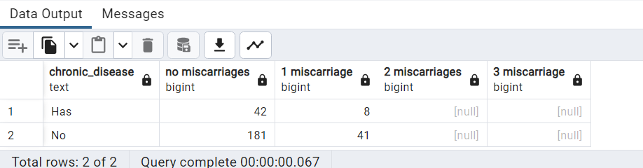

---------------------------------------------------------------------------------------------------------------

**--70. List of patients from rows 30-40 of any table without using the where condition**

SELECT caseid FROM public.fetal_health_risk LIMIT 11 OFFSET 29;

**--Alternate Query--**

select * from public.patient_history

offset 29 fetch next 11 rows only;

select ROW_NUMBER() over (order by caseid) as rownumber, caseid

from public.fetal_health_risk

limit 11

offset 29;

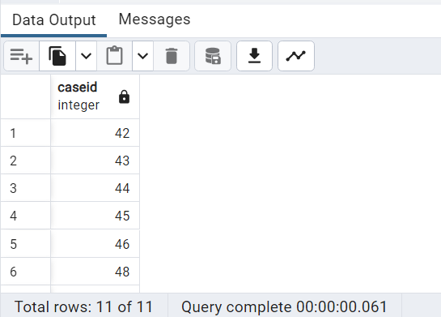

---------------------------------------------------------------------------------------------------------------

**--71. Write a query to find Average age for patients with high blood pressure.**

select avg(age_years_old) from public.patient_history, public.hospitalization_labor

where

hospitalization_labor.caseid=patient_history.caseid and

hospital_systolic_blood_pressure > 130 and

hospital_diastolic_blood_pressure > 90;

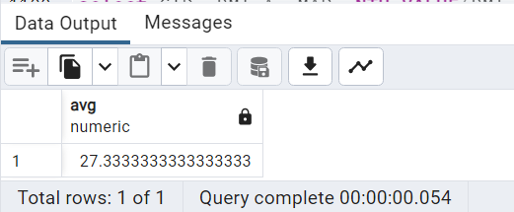

---------------------------------------------------------------------------------------------------------------

**--72. What is the 2nd highest BMI of the patients with 5 highest day time MAP during labor. Use windows functions in solution**

With PatientMap as

(

select patient_history.caseid CID,current_bmi BMI,

round((hospital_systolic_blood_pressure + (hospital_systolic_blood_pressure - hospital_diastolic_blood_pressure)/3),2) AvgMAP

from public.patient_history

join public.hospitalization_labor

on patient_history.caseid=hospitalization_labor.caseid

)

select CID, BMI,AvgMAP, NTH_VALUE(BMI, 2) OVER

(ORDER BY AvgMAP DESC RANGE BETWEEN UNBOUNDED PRECEDING AND UNBOUNDED FOLLOWING) SeconHighestBMI

from PatientMap limit 5;

**--Alternate Query--**

With PatientMap as(

select patient_history.caseid as case_id, patient_history.current_bmi as BMI,

round(hospital_diastolic_blood_pressure+ ((hospital_systolic_blood_pressure-hospital_diastolic_blood_pressure)/3),2) as MAP

from patient_history join hospitalization_labor

on patient_history.caseid = hospitalization_labor.caseid

order by MAP desc nulls last limit 5 )

select case_id,BMI, MAP , nth_value(BMI, 2)

over (order by MAP desc RANGE BETWEEN UNBOUNDED PRECEDING AND UNBOUNDED FOLLOWING)

as second_highest_BMI from PatientMap;

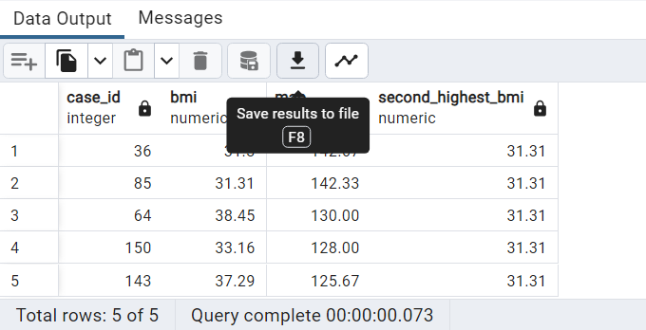

---------------------------------------------------------------------------------------------------------------

**--73. Divide patients by race and partition average Newborn weight into 2 buckets each, label them as appropriate**

With Race as

(

select color_ethnicity Race,avg(newborn_weight) AvgFetus

from public.patient_history

join public.hospitalization_labor on

patient_history.caseid=hospitalization_labor.caseid

group by 1

order by 1

),

NewFetus as

(

Select Race,AvgFetus, NTILE(2) Over(Partition by Race order by AvgFetus) NewbornWt from Race order by 3

)

Select Race,NewbornWt,

Case when NewbornWt=1 then 'Lower Percentile'||'-'||NewbornWt

when NewbornWt=2 then 'Higher Percentile'||'-'||NewbornWt

end FetusGroup

from NewFetus;

--Alternate Query--

With Race as

(

select color_ethnicity Race,newborn_weight baby_weight,

NTILE(2) Over(Partition by color_ethnicity order by newborn_weight) NewbornWt

from public.patient_history join public.hospitalization_labor on patient_history.caseid=hospitalization_labor.caseid

where newborn_weight is not null

)

Select Race,round(avg(baby_weight),2) baby_weight_avg,

Case when NewbornWt=1 then 'Lower Percentile - '||NewbornWt when NewbornWt=2 then 'Higher Percentile - '||NewbornWt end percentile_group

from Race group by Race,percentile_group order by race,percentile_group desc;

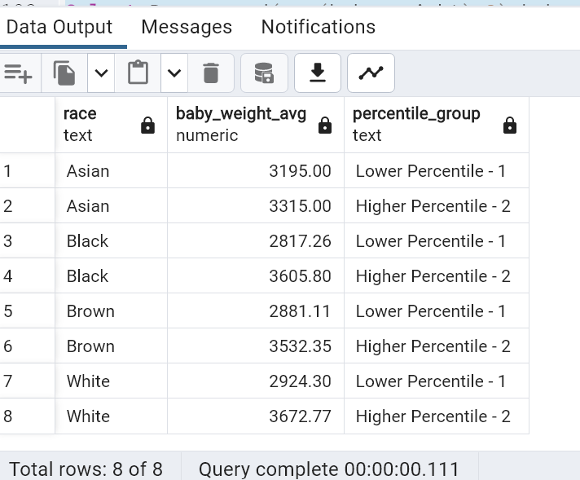

---------------------------------------------------------------------------------------------------------------

**--74. Write a query to fetch the first 10, caseids, ages and all 3 maternal trimester weights using a recursive Common Table Expression**

with recursive patient_hierarchy as (

select 1 as S_No,caseid,age_years_old,current_maternal_weight_1st_tri,current_maternal_weight_2nd_tri,current_maternal_weight_3rd_tri

from patient_history

where caseid=1

union all

select S_No+1, ph.caseid,

ph.age_years_old,ph.current_maternal_weight_1st_tri,ph.current_maternal_weight_2nd_tri,ph.current_maternal_weight_3rd_tri

from patient_history ph, patient_hierarchy hier where ph.caseid = S_No+1

)

select hier.caseid,

hier.age_years_old,hier.current_maternal_weight_1st_tri,hier.current_maternal_weight_2nd_tri,hier.current_maternal_weight_3rd_tri

from patient_hierarchy hier limit 10;

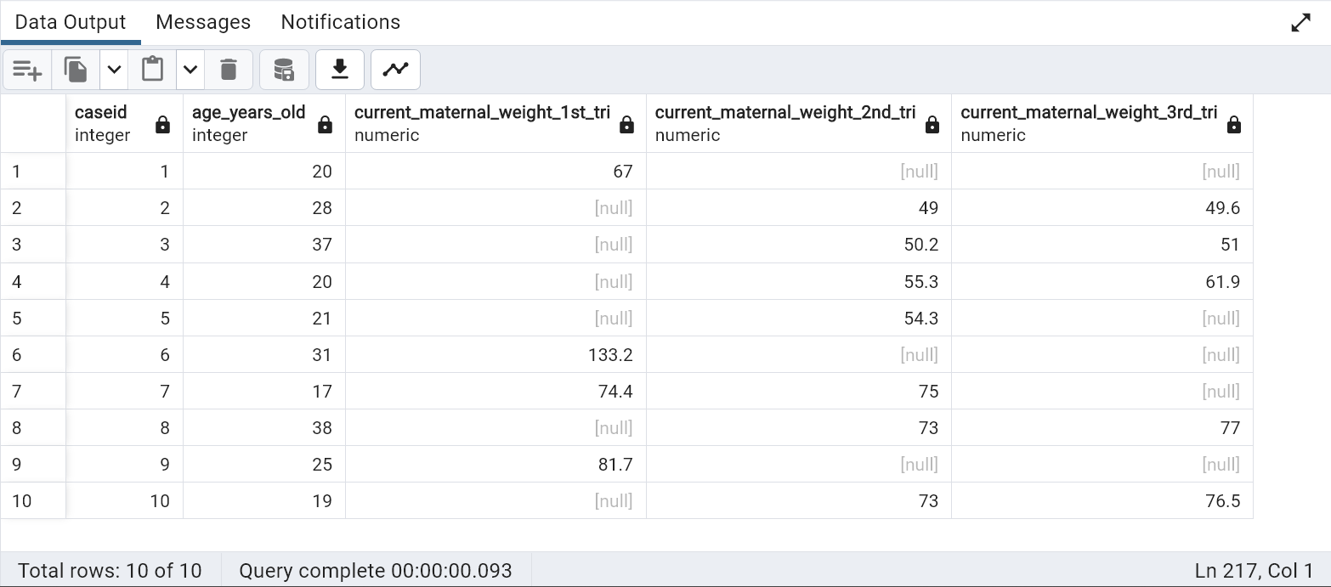

---------------------------------------------------------------------------------------------------------------

--75. Create a pie chart based on age vs tobacco use

SELECT

tobacco_use,avg(age_years_old) from

public.patient_history,public.fetal_health_risk

where patient_history.caseid=fetal_health_risk.caseid

group by 1;

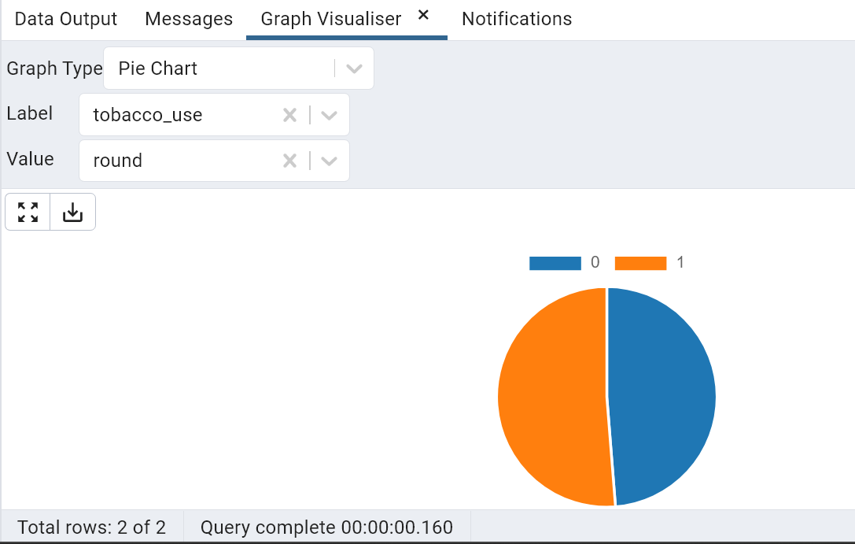

---------------------------------------------------------------------------------------------------------------

**--76. How many prenatal visits did GDM (gestational diabetes mellitus) patients have on average?**

select avg(number_prenatal_appointments) from public.hospitalization_labor,public.fetal_health_risk

where

hospitalization_labor.caseid=fetal_health_risk.caseid and

gestational_diabetes_mellitus=1;

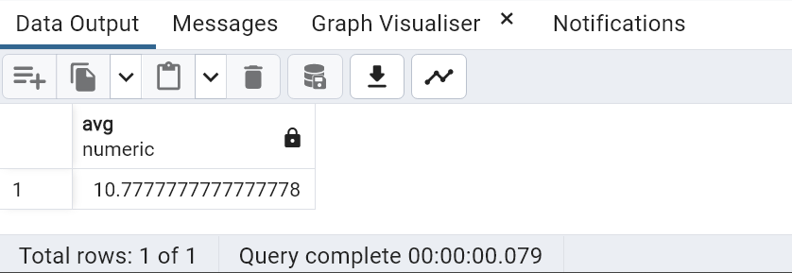

---------------------------------------------------------------------------------------------------------------

**--77. Display mean, Interquartile range, 2 standard deviations above mean, and 2 standard deviations below mean of any one systolic Blood pressure for all patients in the database grouped by race**

Select color_ethnicity,

percentile_cont(0.5) WITHIN GROUP (ORDER BY right_systolic_blood_pressure) +stddev_pop(right_systolic_blood_pressure) OneStdDevAboveMedian,

percentile_cont(0.5) WITHIN GROUP (ORDER BY right_systolic_blood_pressure) +2*stddev_pop(right_systolic_blood_pressure) TwoStdDevBAboveMedian,

percentile_cont(0.5) WITHIN GROUP (ORDER BY right_systolic_blood_pressure) MedianHB1AC,

percentile_cont(0.5) WITHIN GROUP (ORDER BY right_systolic_blood_pressure) -stddev_pop(right_systolic_blood_pressure) OneStdDevBelowMedian,

percentile_cont(0.5) WITHIN GROUP (ORDER BY right_systolic_blood_pressure) -2*stddev_pop(right_systolic_blood_pressure) TwoStdDevBelowMedian

from public.maternal_labs,public.patient_history

where maternal_labs.caseid= patient_history.caseid

group by color_ethnicity;

--Alternate Query--

Select color_ethnicity,

round(avg(right_systolic_blood_pressure),2) as mean,

percentile_cont(0.75) WITHIN GROUP (ORDER BY right_systolic_blood_pressure) - percentile_cont(0.25)

WITHIN GROUP (ORDER BY right_systolic_blood_pressure) as iqr,

round(avg(right_systolic_blood_pressure)+2*stddev_pop(right_systolic_blood_pressure),2) as Two_StdDev_AboveMean,

round(avg(right_systolic_blood_pressure)-2*stddev_pop(right_systolic_blood_pressure),2) as Two_StdDev_BelowMean

from public.maternal_labs,public.patient_history

where maternal_labs.caseid= patient_history.caseid

group by color_ethnicity;

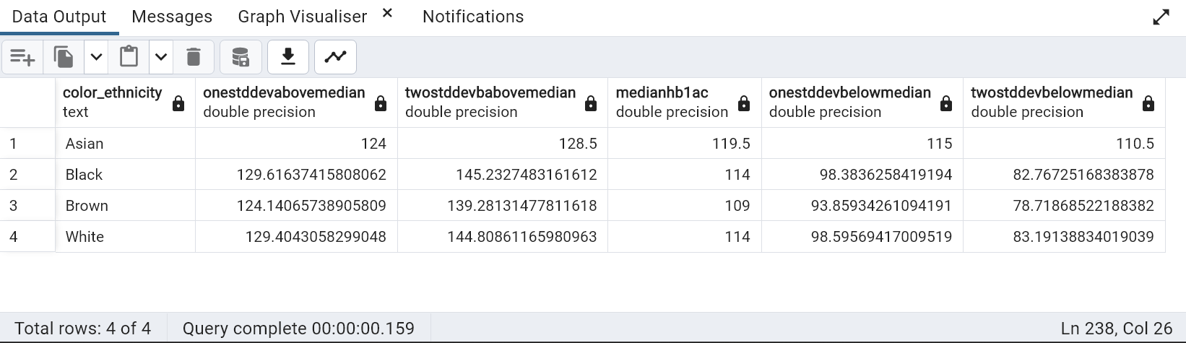

---------------------------------------------------------------------------------------------------------------

**--78. Display the number of mothers who had cesareans in 3 categories: those that had been tobacco users for under 2 years, 2-10 years, and over 10 years "**

select count(f1.caseid),

(case when tobacco_use_in_months < 24 then 'Under 2 yrs'

when tobacco_use_in_months < 120 then '2-10 yrs'

else 'more than 10 yrs' end) tobacco_use_duration

from fetal_health_risk f1,hospitalization_labor l1

where f1.caseid = l1.caseid

and tobacco_use_in_months is not null

group by 2

order by 1

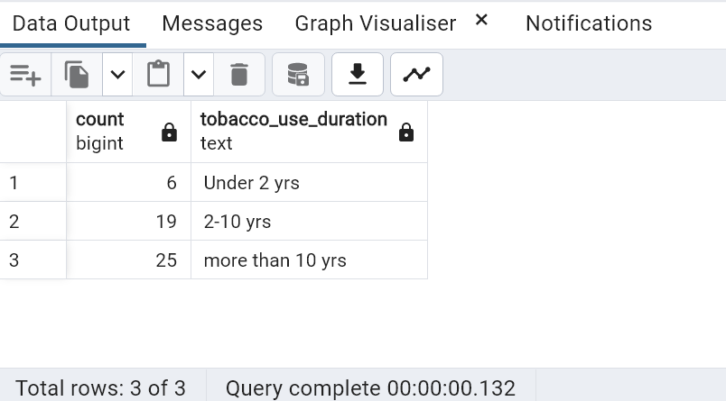

---------------------------------------------------------------------------------------------------------------

--79. Display any 10 random rows from patient history table

select * from public.patient_history

order by random()

limit 10;

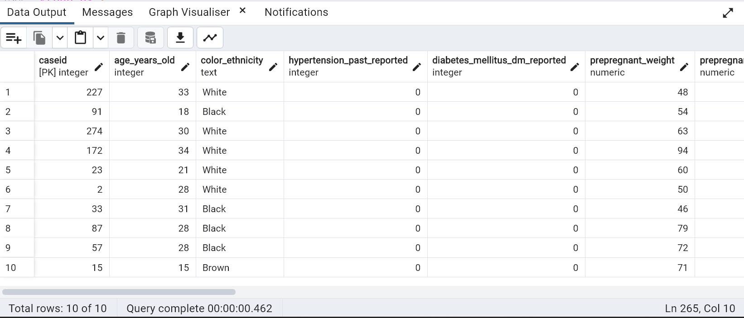

---------------------------------------------------------------------------------------------------------------

--80. Provide the cumulative distribution for delivery mode based on BMI below or above 30.

select delivery_mode,BMICAT, CUME_DIST() OVER ( ORDER BY BMICAT) FROM

(SELECT ( CASE when prepregnant_bmi<=30 then 'Normal Range' else 'Overweight' END) BMICAT, delivery_mode

from patient_history, hospitalization_labor where patient_history.caseid = hospitalization_labor.caseid

and prepregnant_bmi is not null

and delivery_mode is not null group by 1,2 )SubQuery



